**Travel Memory**

**Things to Remember:**

1. Installed Backend and Frontend on same ec2 machine considering cost factor. If we need only 1 instance of each then why do we need to run 2 ec2 machine. Instead, we can add up 1 more ec2 using AMI/scaling group whenever it reaches thresold
2. Have not added scripts to start the backend/frontend. This can we added in user-data from advanced settings while spinning up new ec2

**Architecture Diagram**

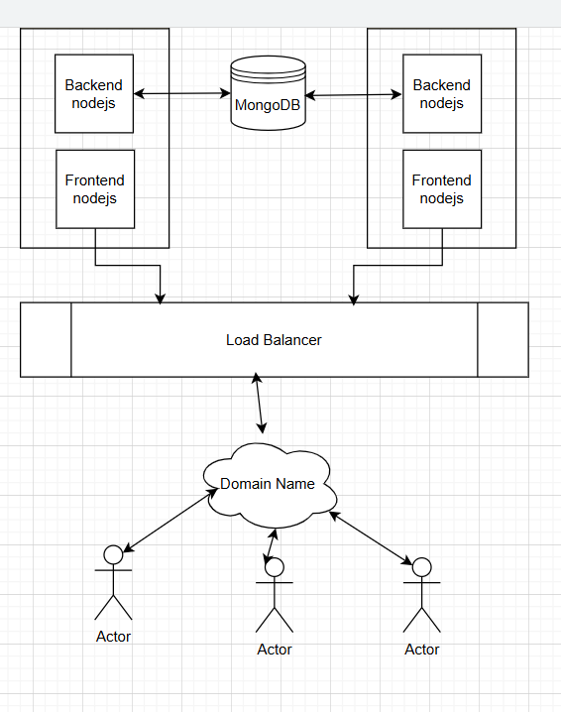

**Pre-requisites**

On Cloud Mongo DB (if not available, follow below steps)

* Sign in using **Google** or **GitHub** account

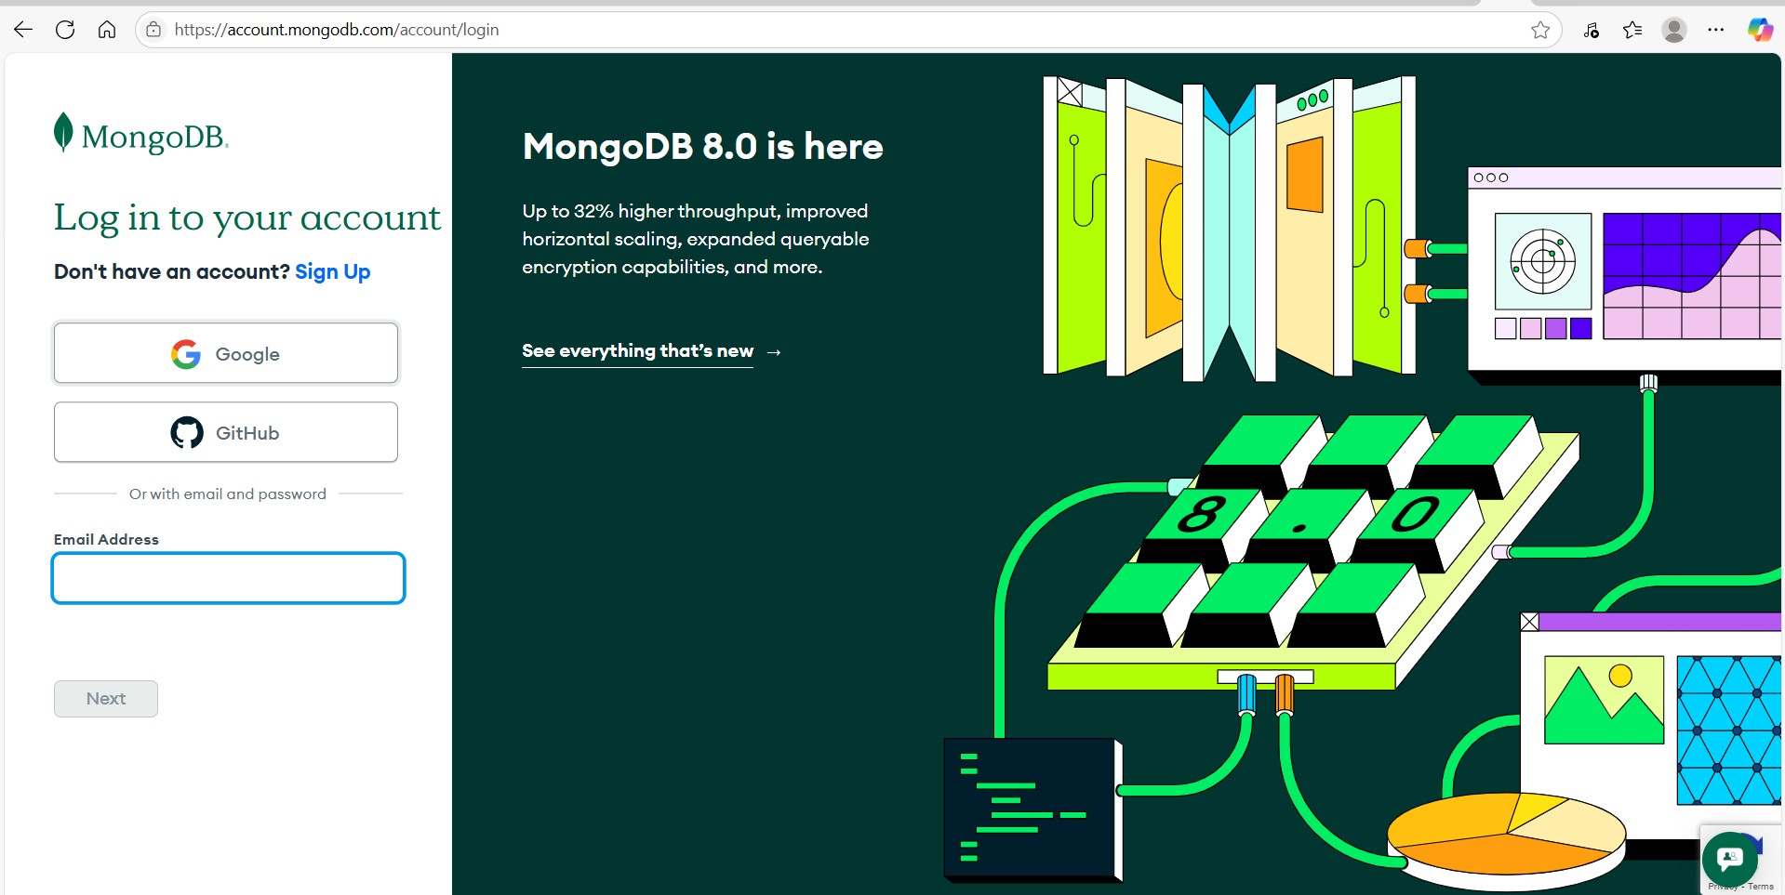

* Go to **Clusters** option available on left hand side and create free cluster

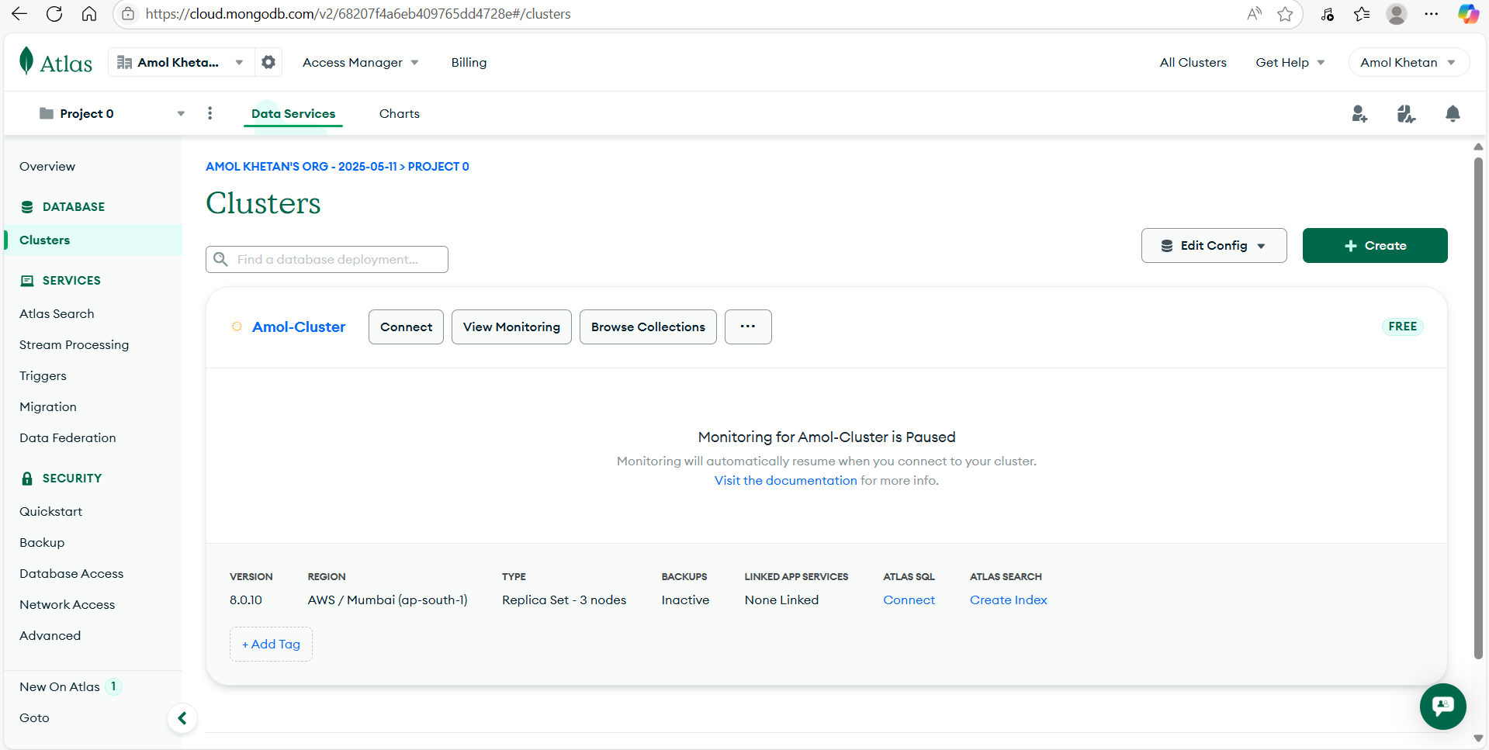

* Add Database user using **Database Access** option from left hand side bar

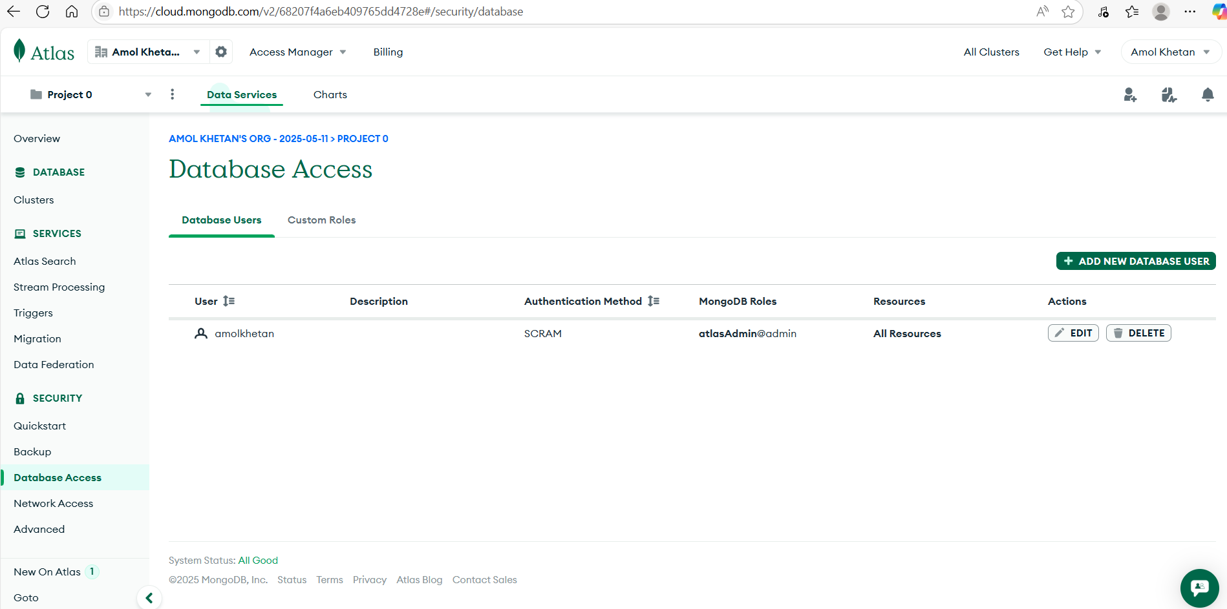

* Go to **Network Access** from left hand side and add IP address to allow traffic from anywhere

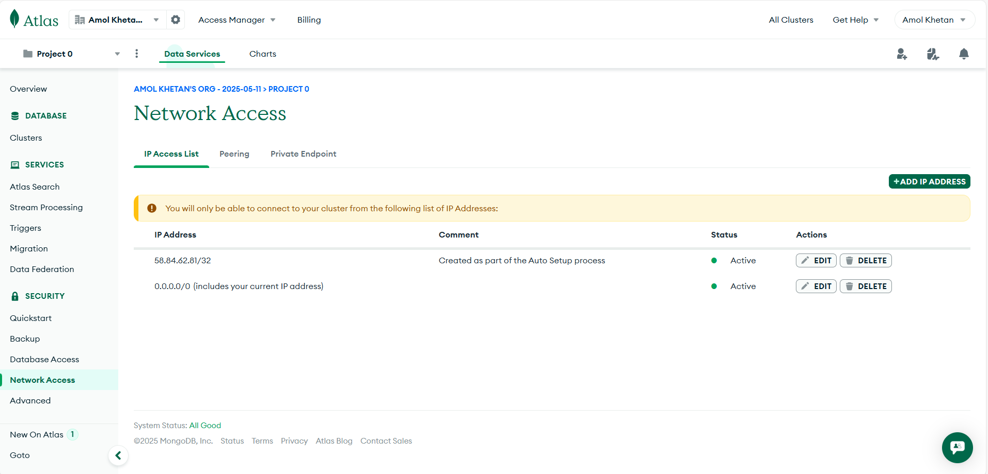

* Now, Click on **Clusters** and try to connect it. Copy the connection string and replace the password with actual password. Sample string/uri

**mongodb+srv://amolkhetan:<db_password>@amol-cluster.smlmwf1.mongodb.net/**

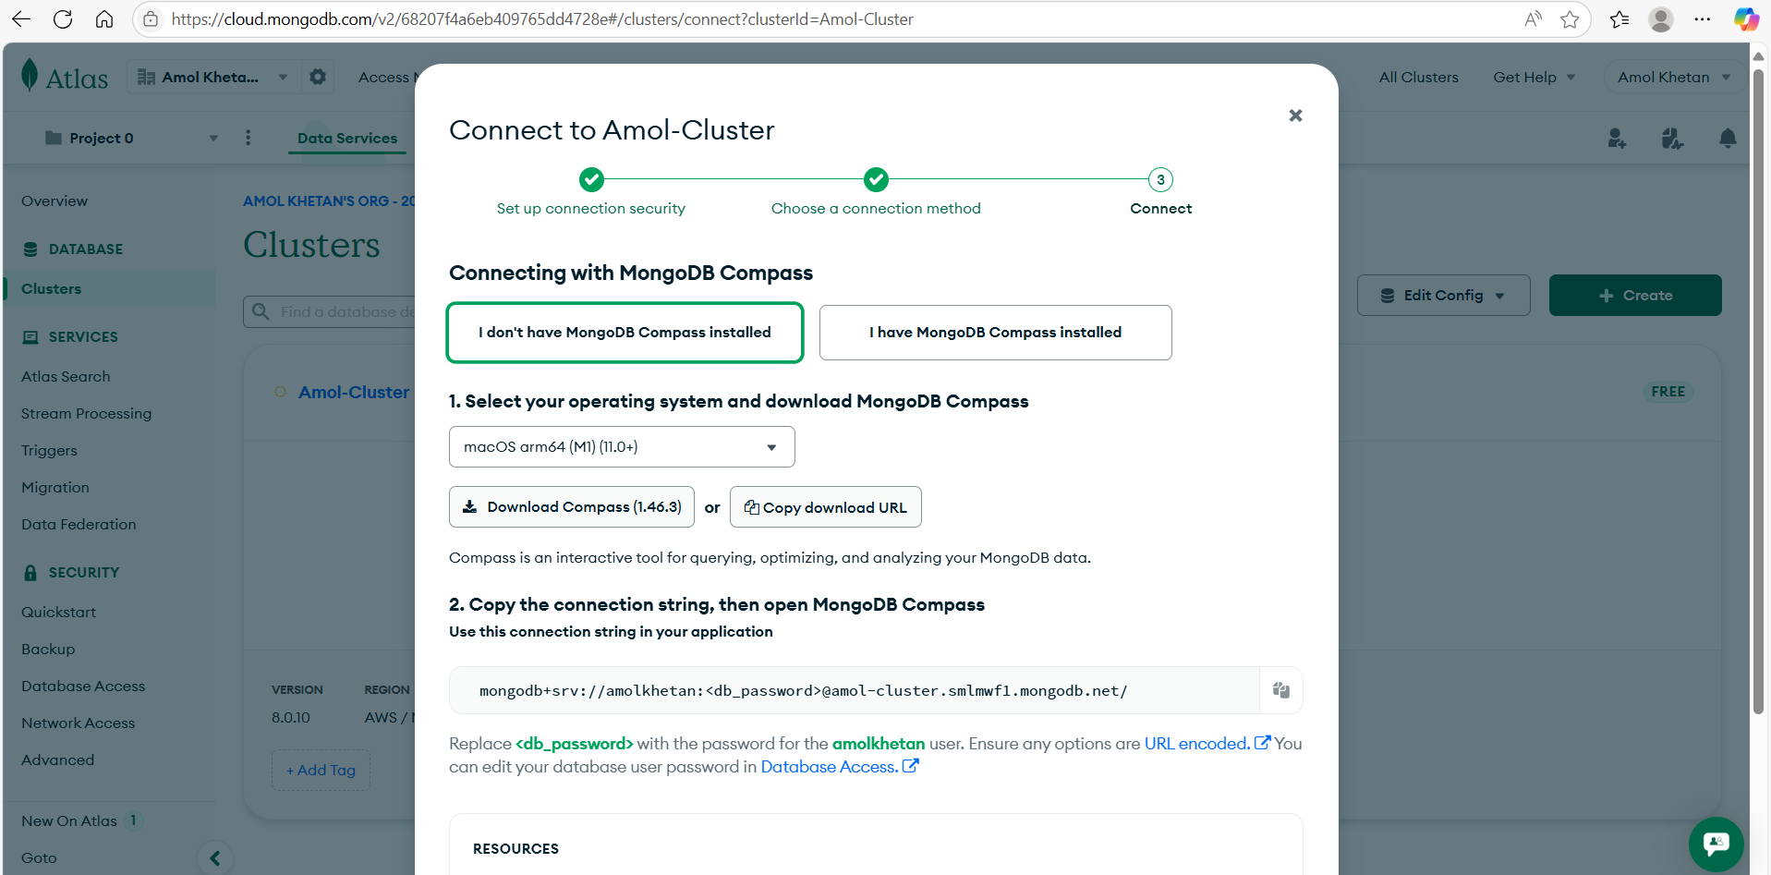

* Install **MongoDB Compass** as per your OS e.g. Windows, Mac, linux. Click on Add Connection and replace the uri string with your uri which you got from MongoDB Atlas and save.

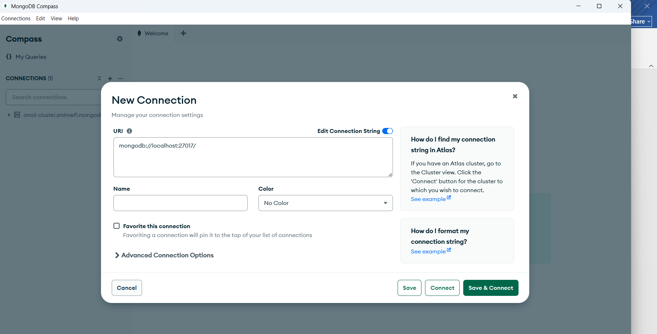

On Successful connection, you will see something like below

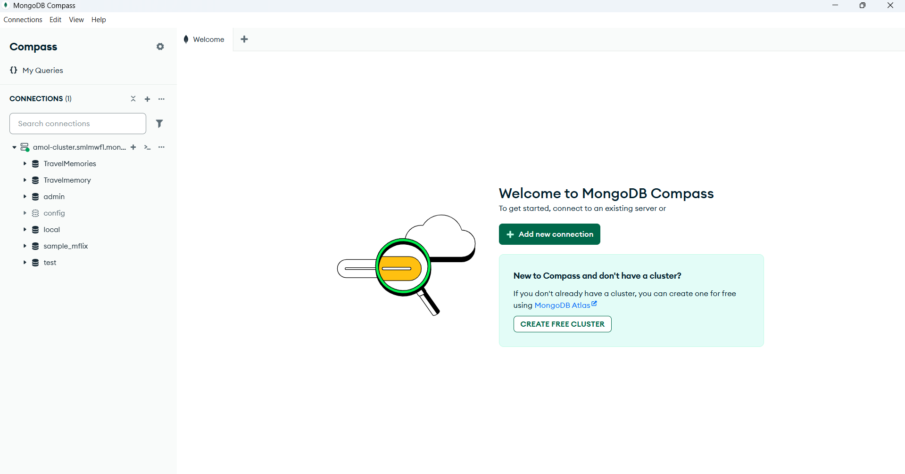

**Application Deployment**

**Backend Configuration**

**Step 1**: Login to AWS account and launch an EC2 machine with desired config in allocated or selected region like **us-west-2**. Sample mentioned below:

* AMI ubuntu
* t2.micro
* 8 gb storage

Create new Key pair/security group or use existing one. In security group, ensure that necessary protocols and ports are opened

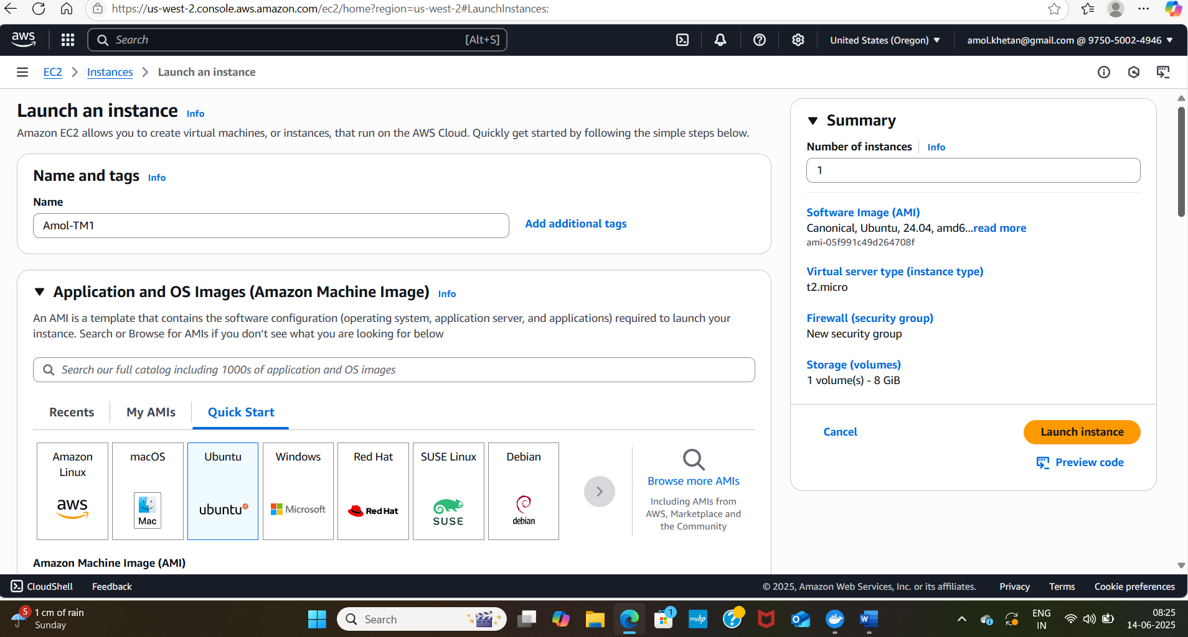

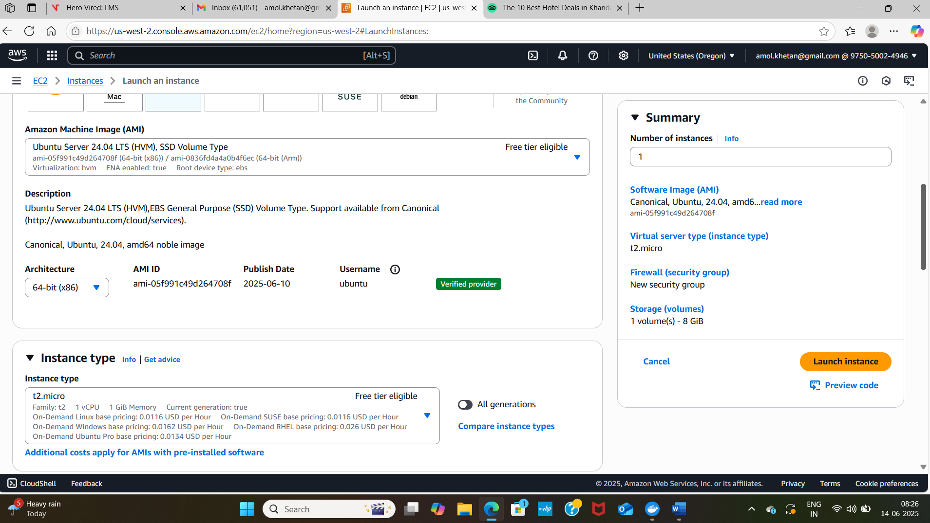

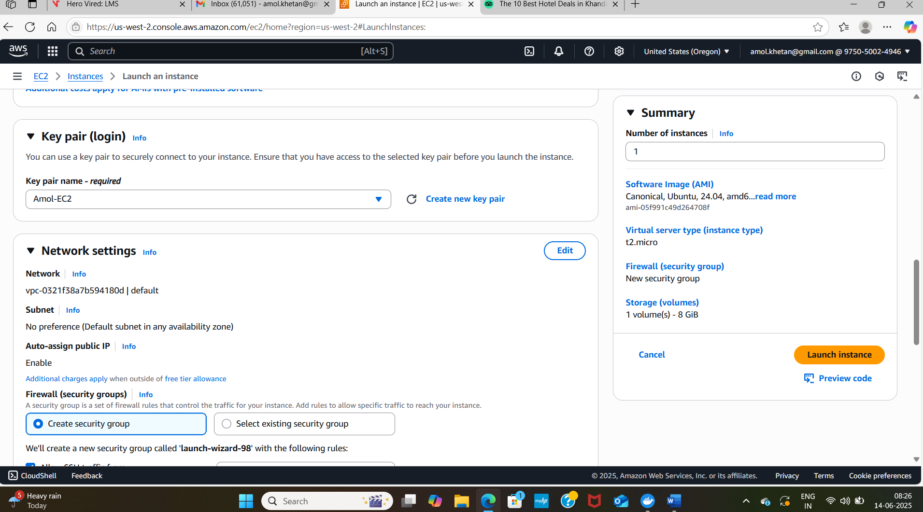

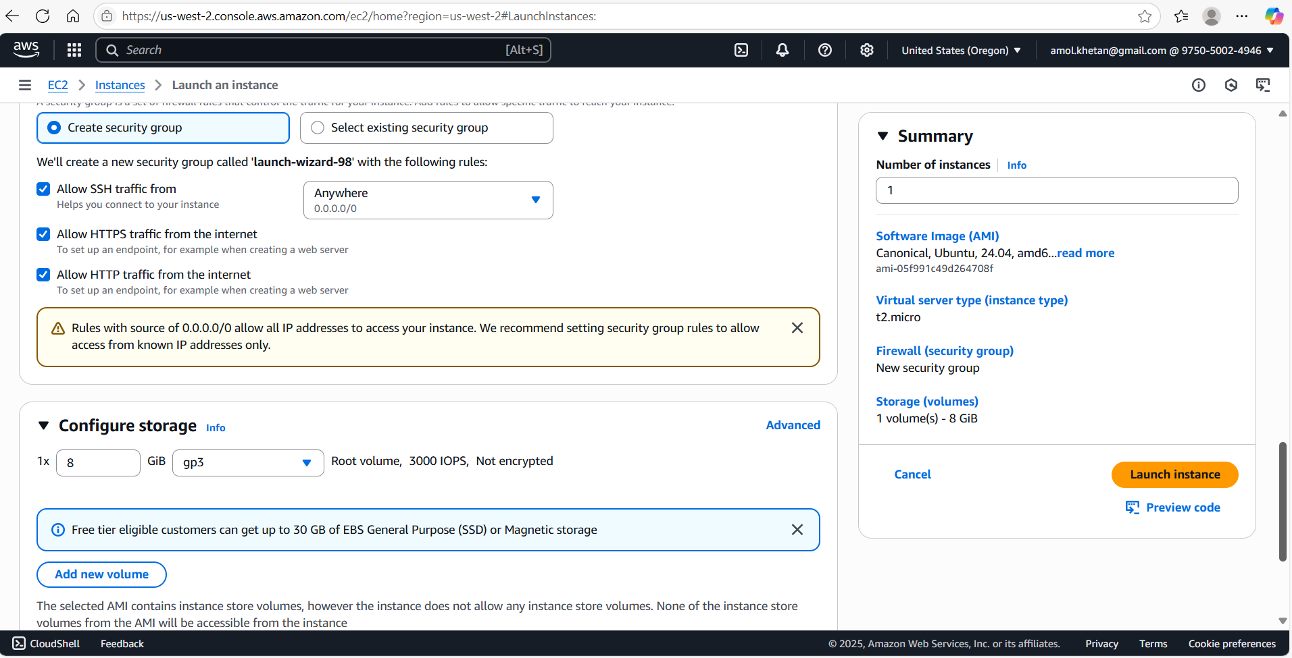

Once everything is selected, click on **Launch Instance**

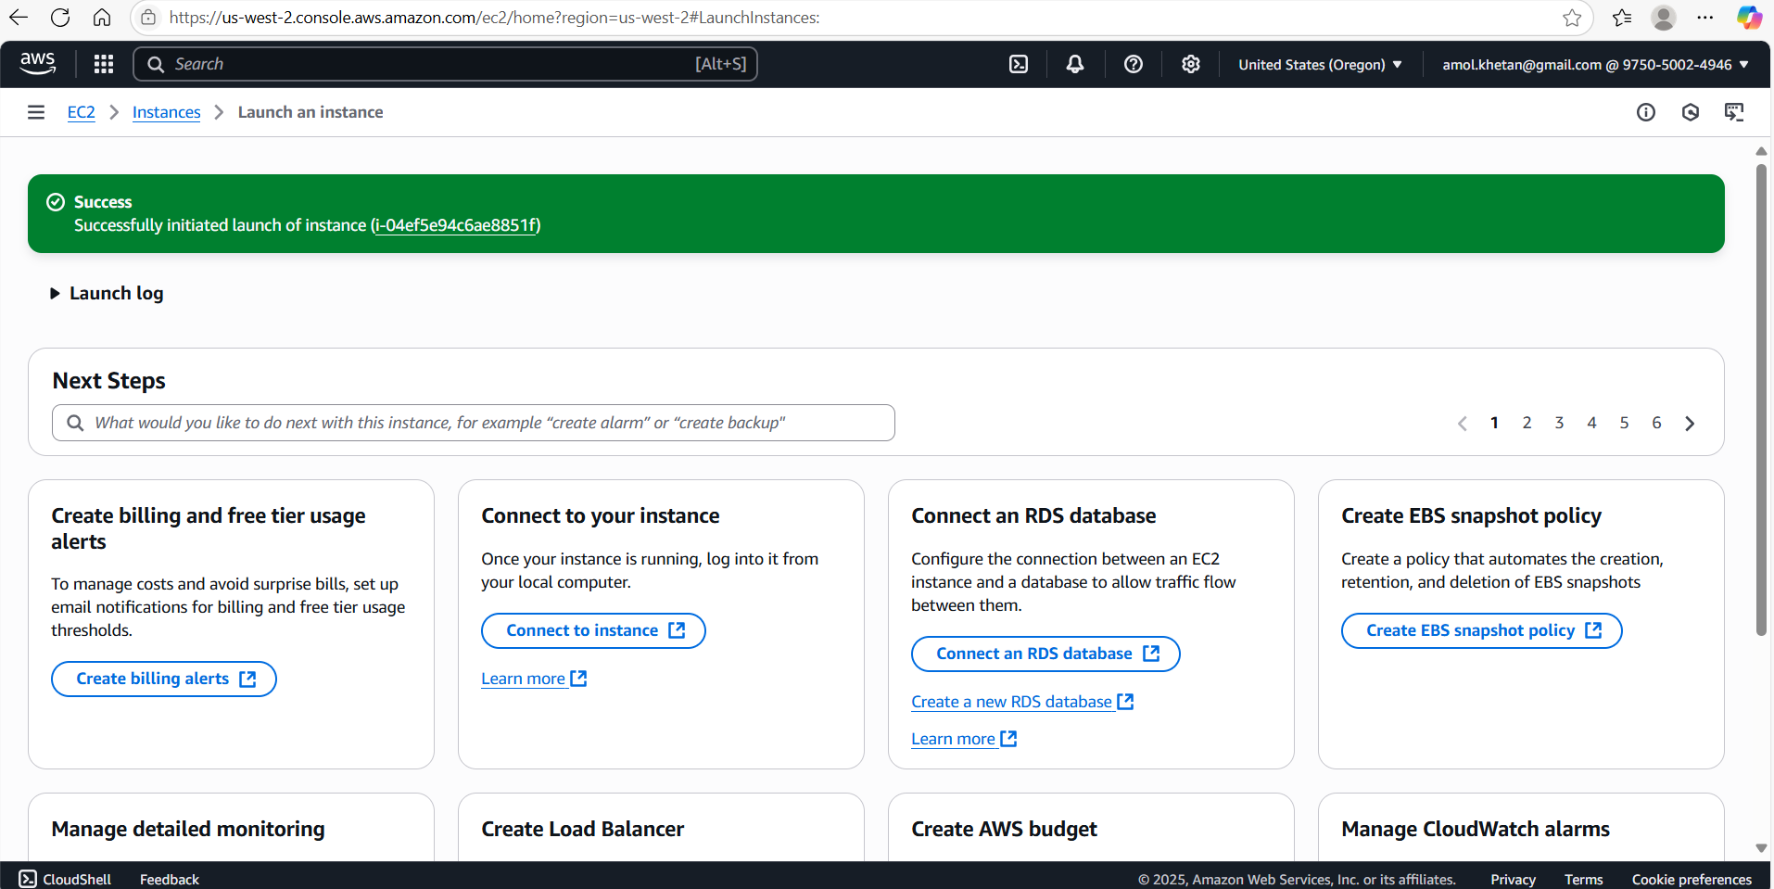

**Step 2:** Connect to EC2 Instance using **EC2 Instance Connect or Putty** and clone the repo there

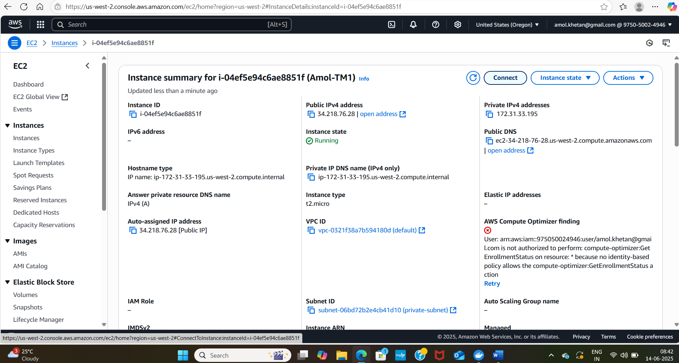

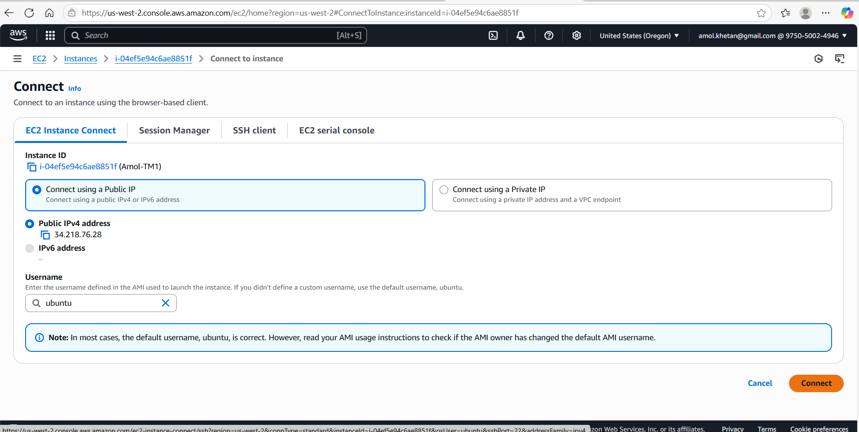

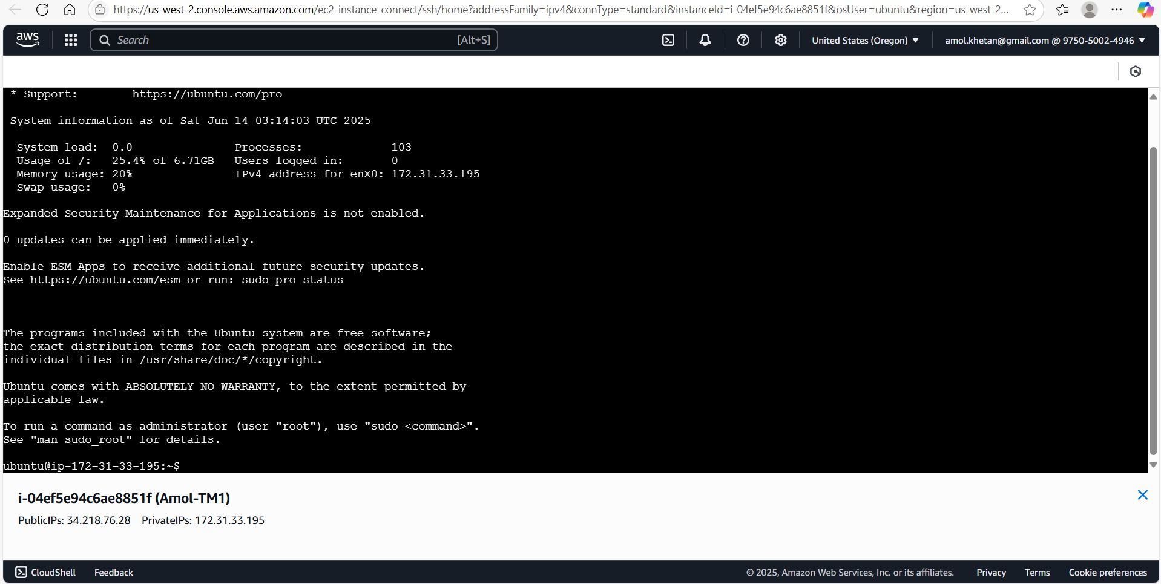

Now, run **sudo apt update** to update ec2 machine

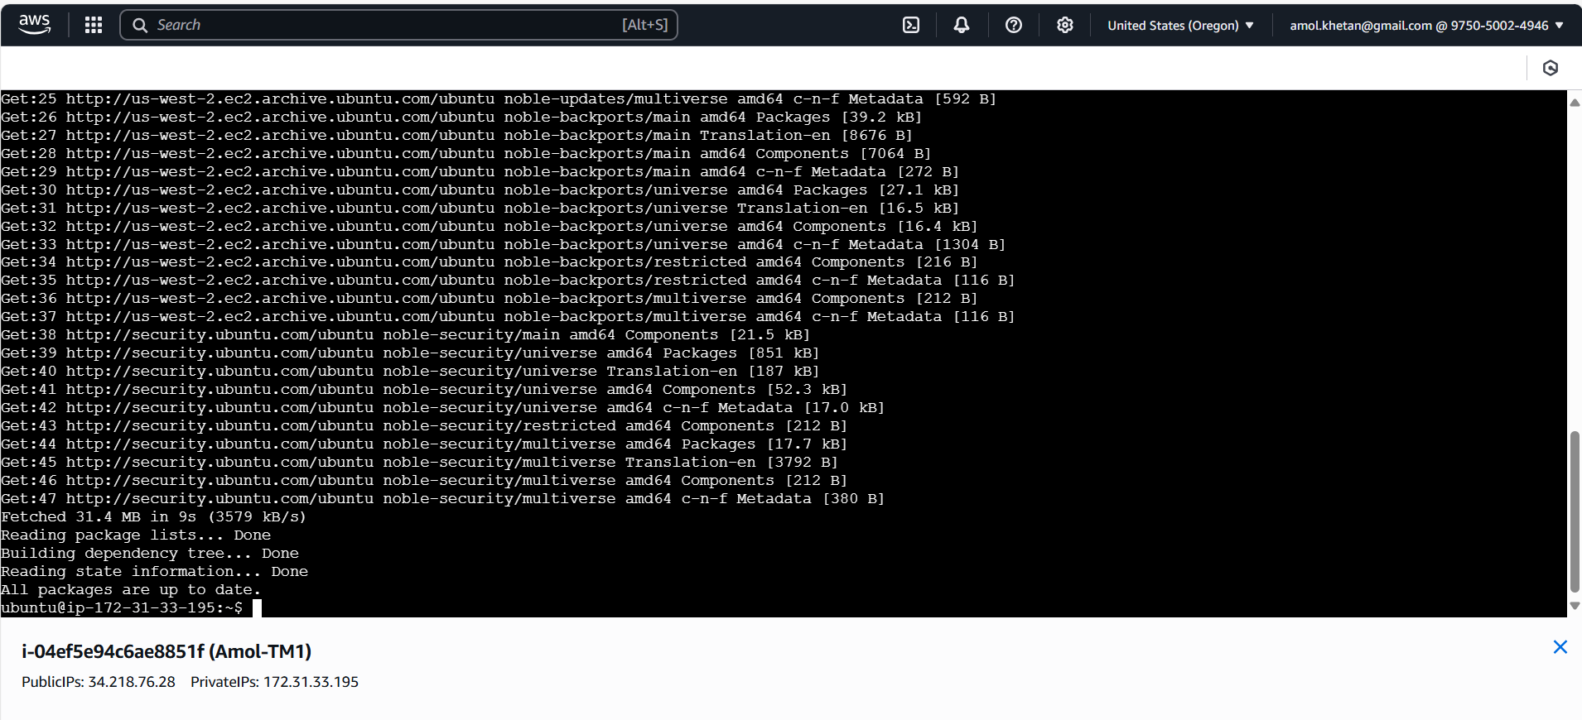

Run **Git Clone** [**https://github.com/UnpredictablePrashant/TravelMemory**](https://github.com/UnpredictablePrashant/TravelMemory)to copy repo on EC2 machine

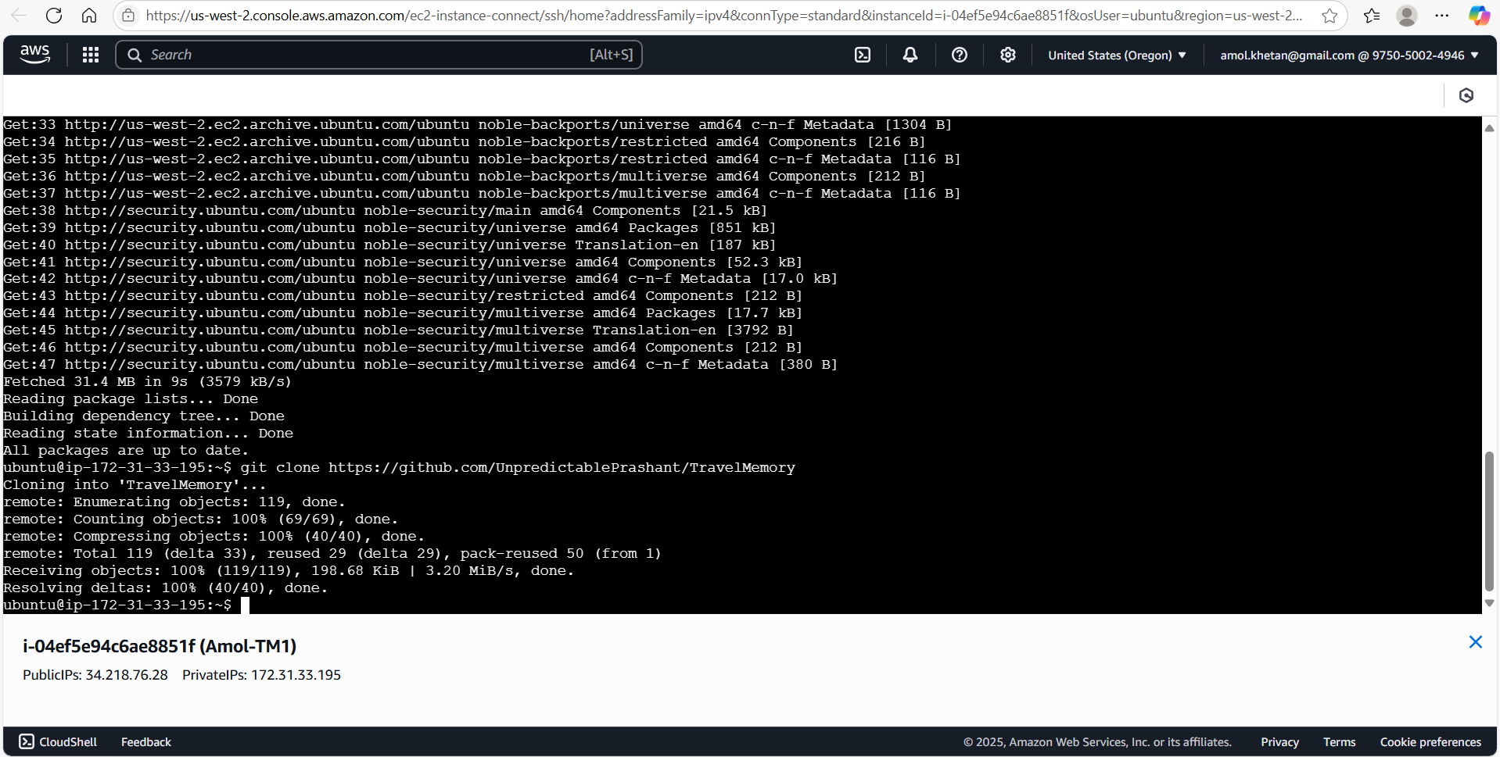

**Step 3**: Set up Backend

* install nodejs using below commands:

curl -s https://deb.nodesource.com/setup_18.x | sudo bash

sudo apt install -y nodejs

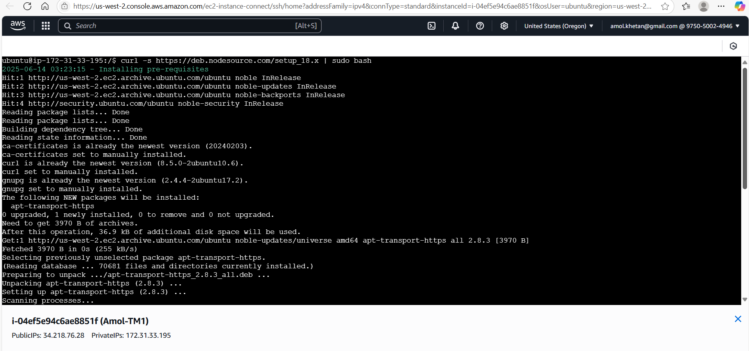

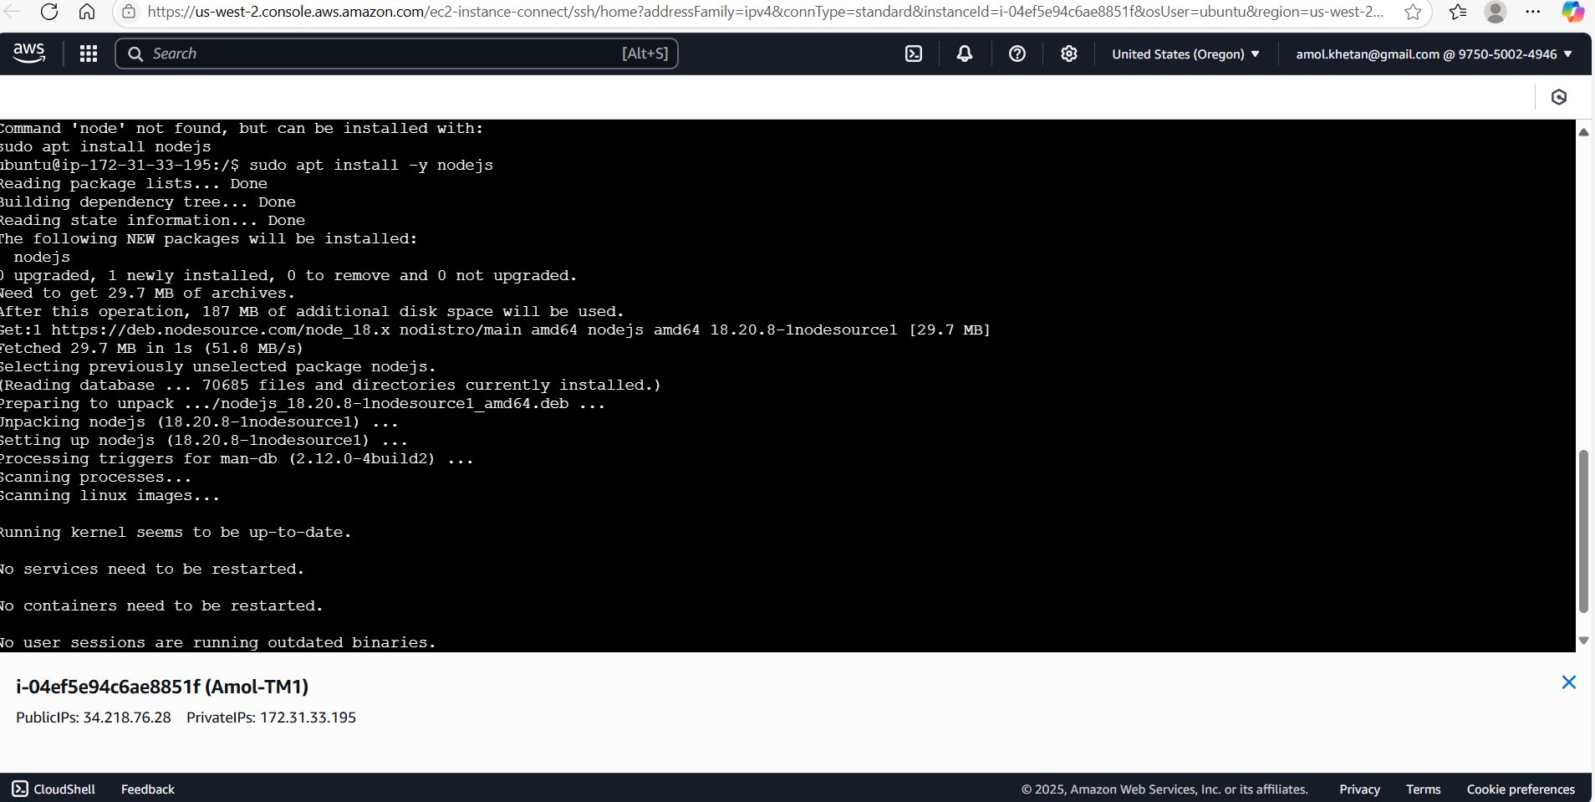

Install npm using

sudo install npm -y

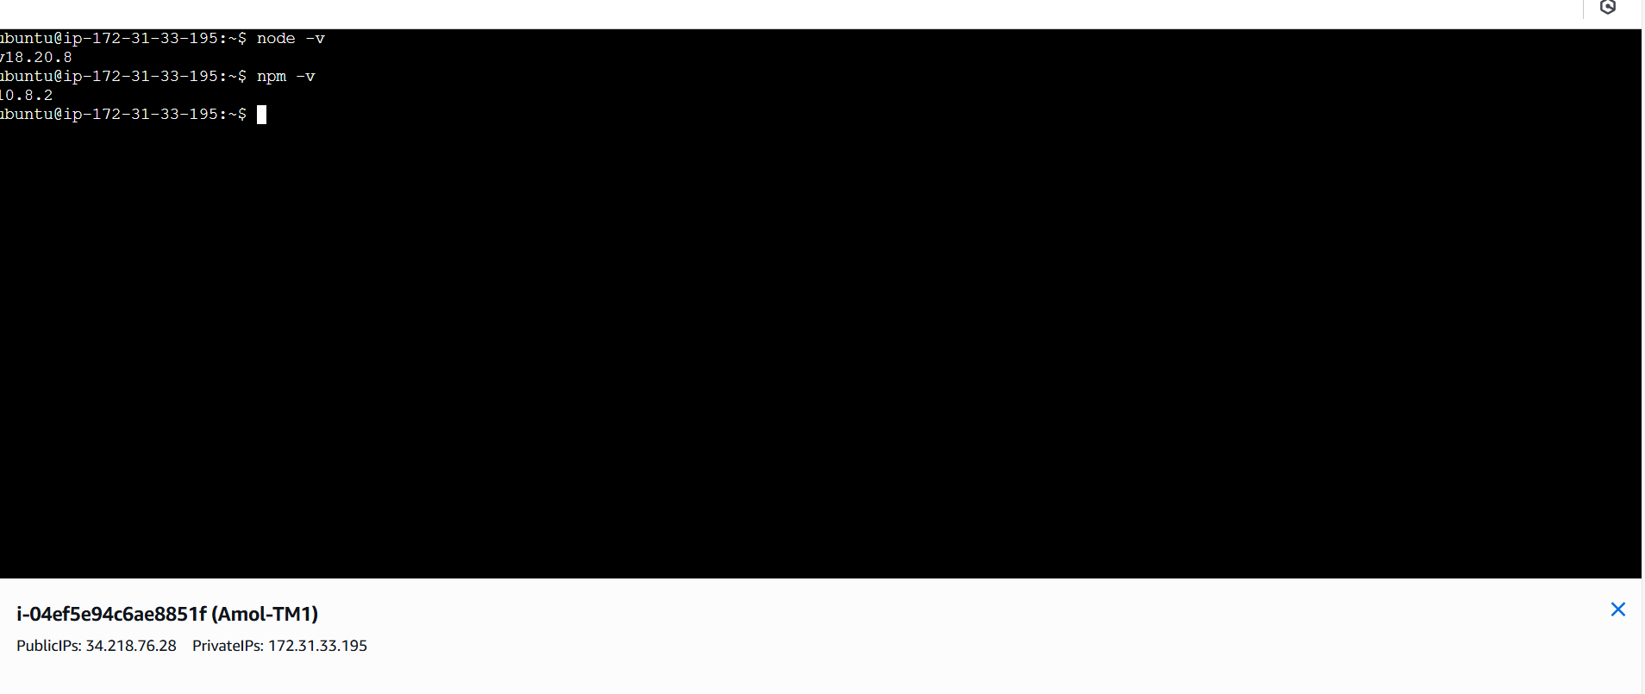

Go to Backend folder and update the port as **3000** in index.js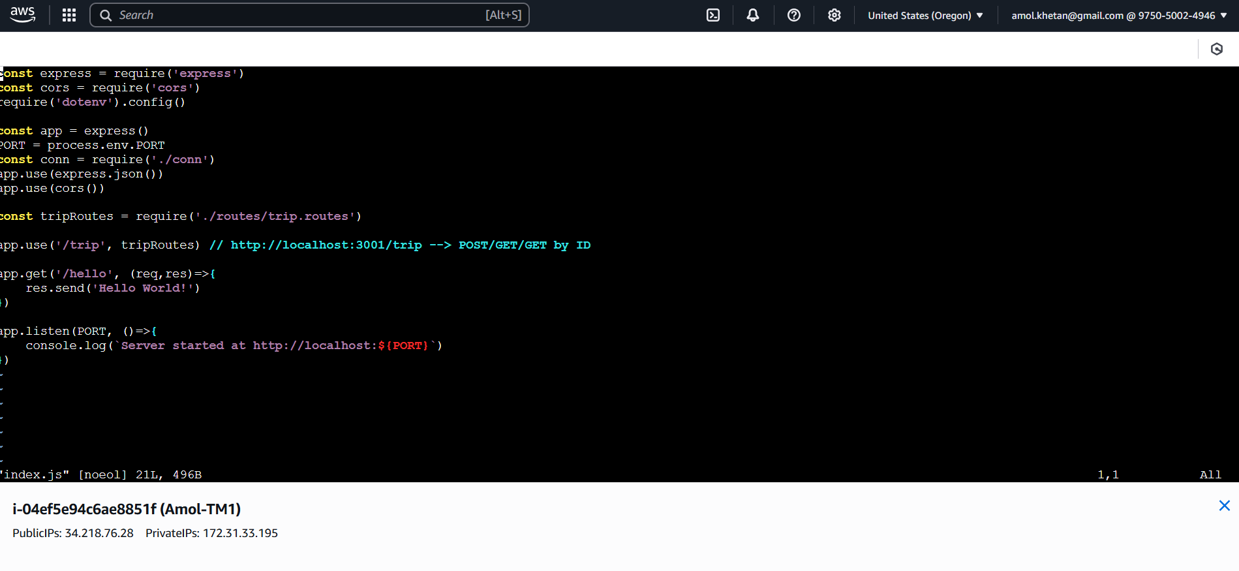

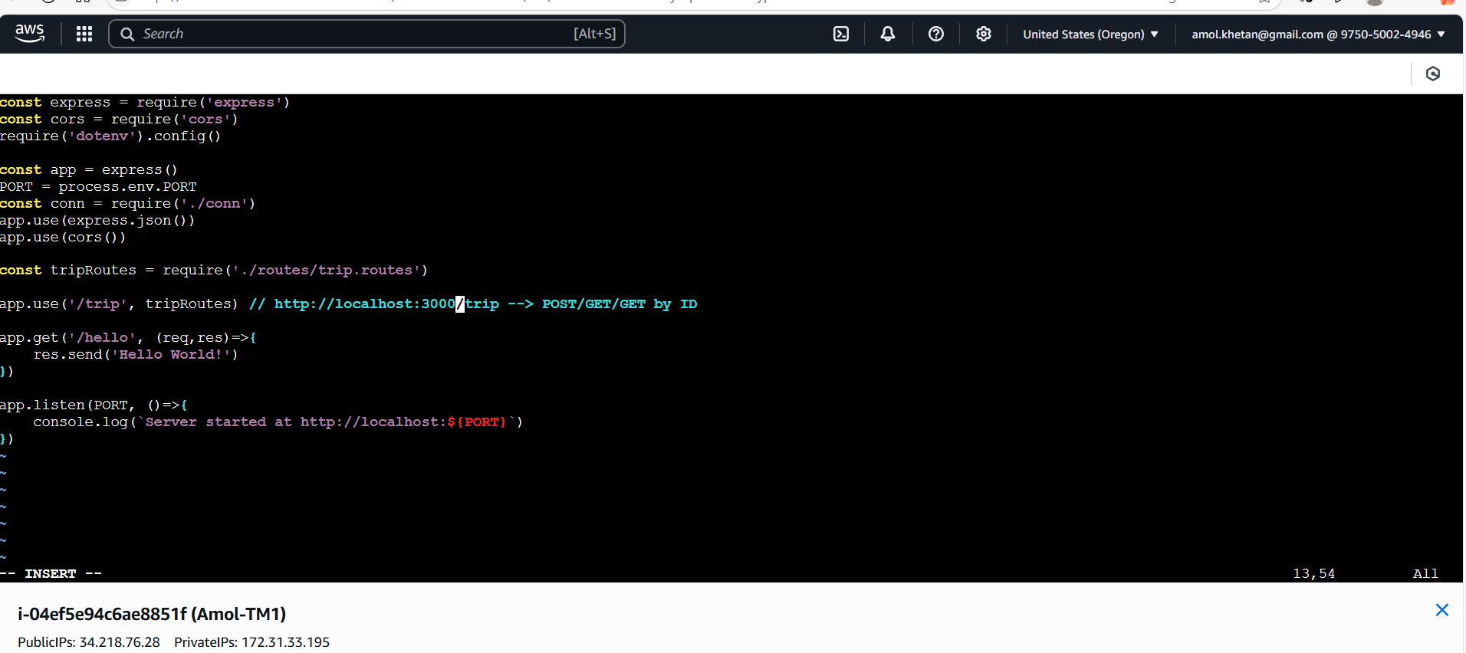

**Create .env file like below**

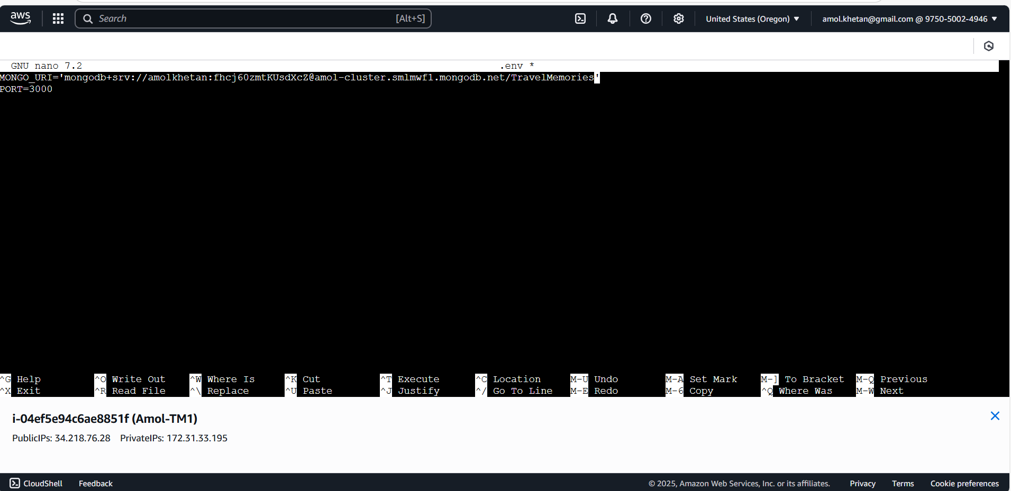

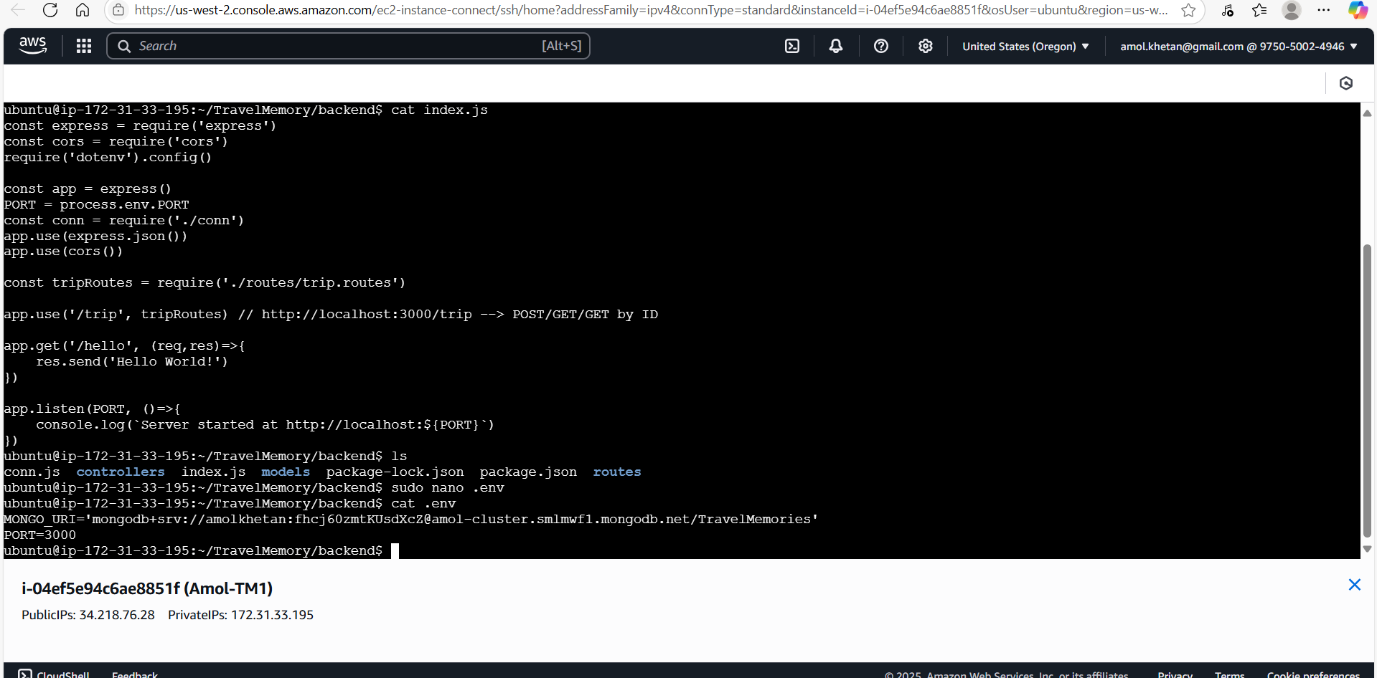

Run npm to download dependencies.

sudo npm install

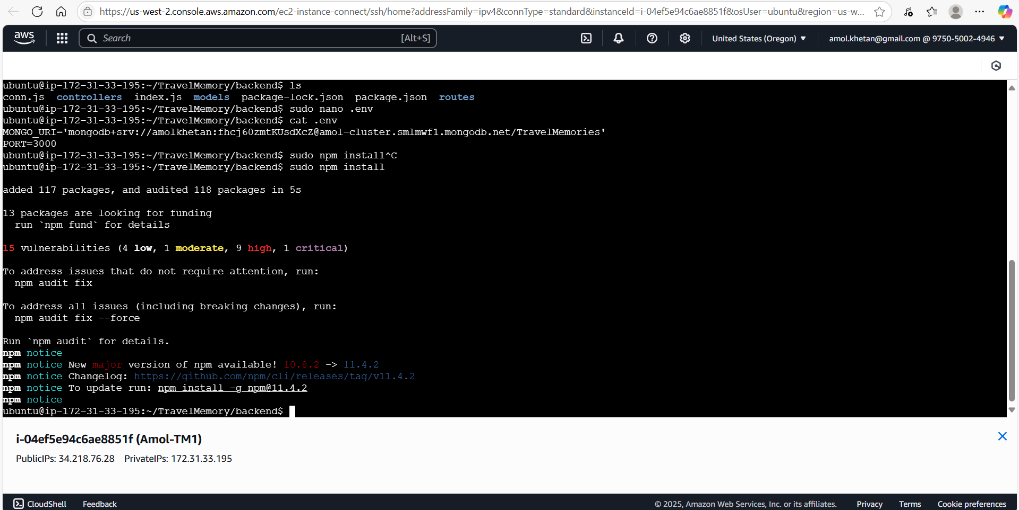

Start Backend using

Sudo node index.js

Test backend using private ip of ec2 with port 3000 as shown in below screenshot using

routes as hello

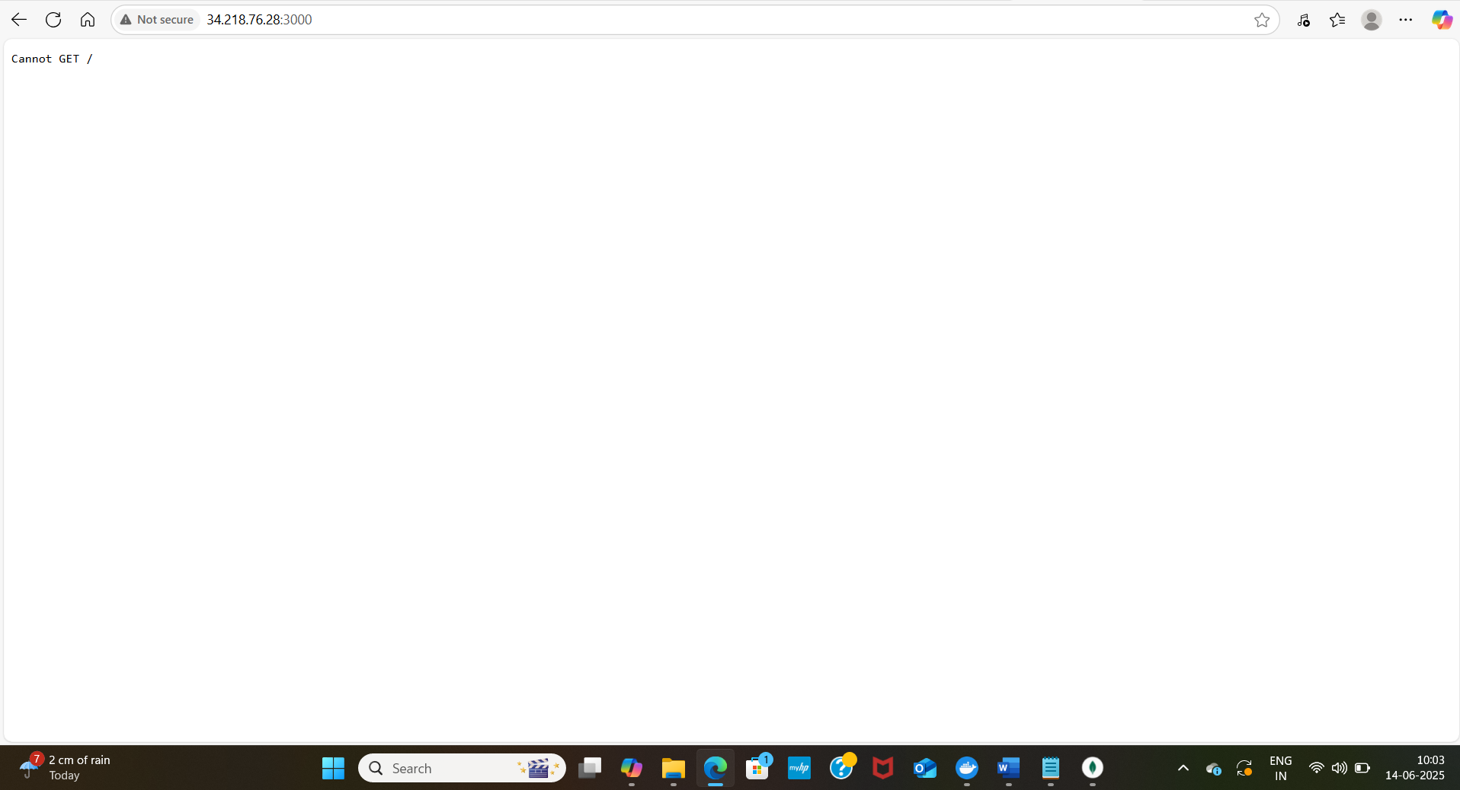

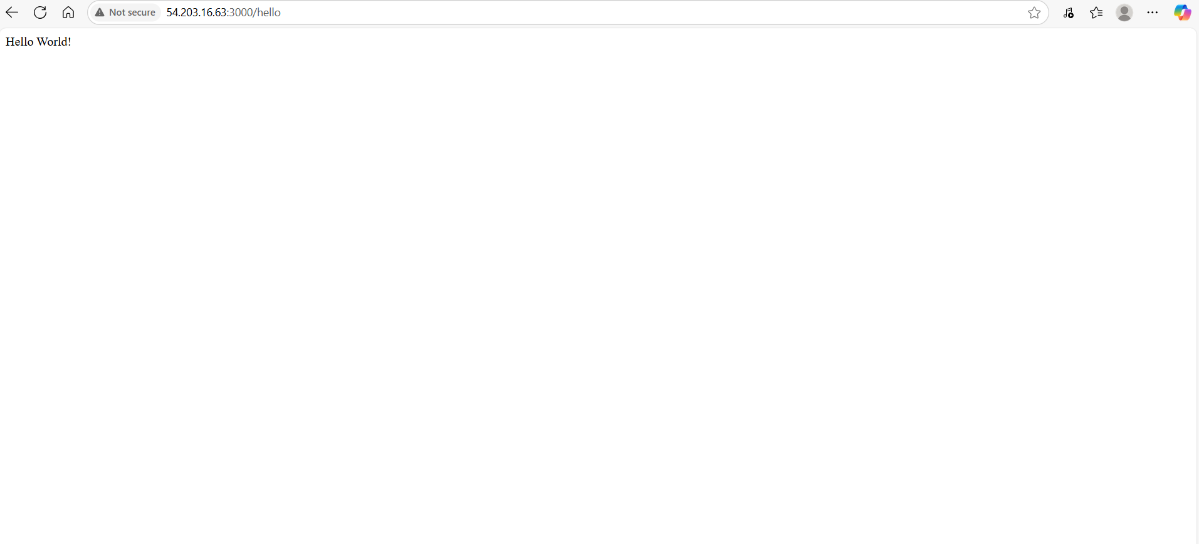

Now, install nginx. This can be done prior to backend set up, but wanted to check if backend works without ngnix.

sudo apt install nginx

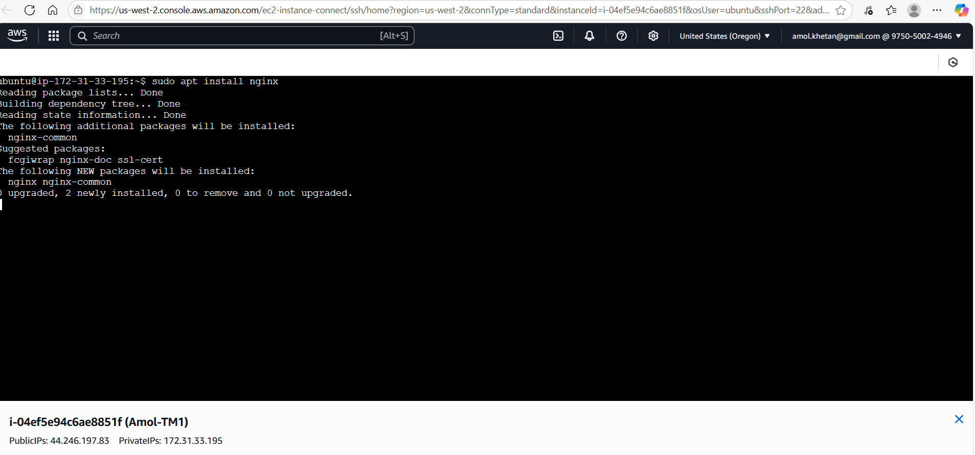

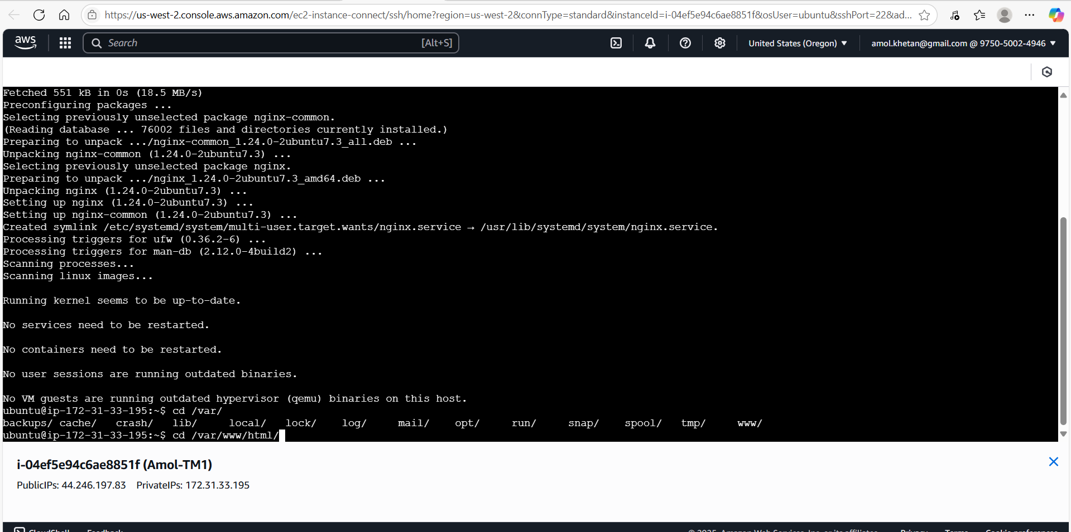

Go to **/etc/nginx/sites-available/** and Edit **default**

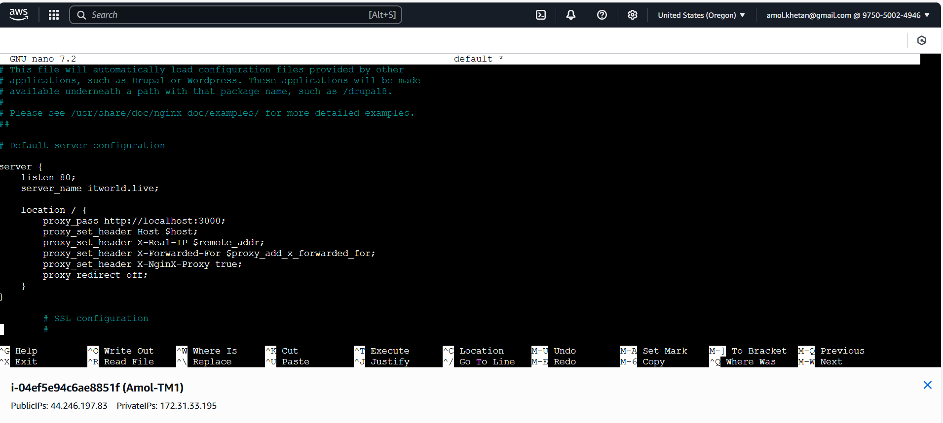

sudo systemctl restart nginx

**Step 3: Frontend and Backend Connection**

Go to frontend folder and create .env

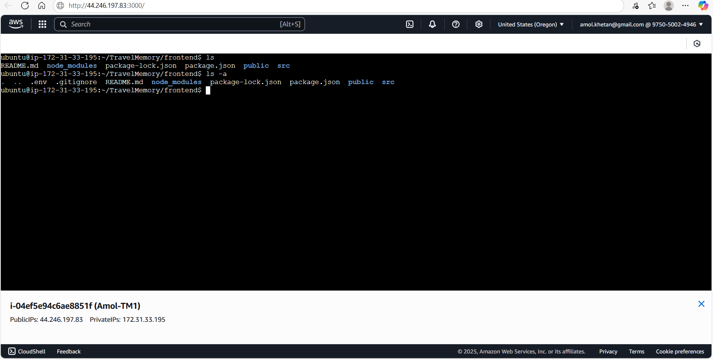

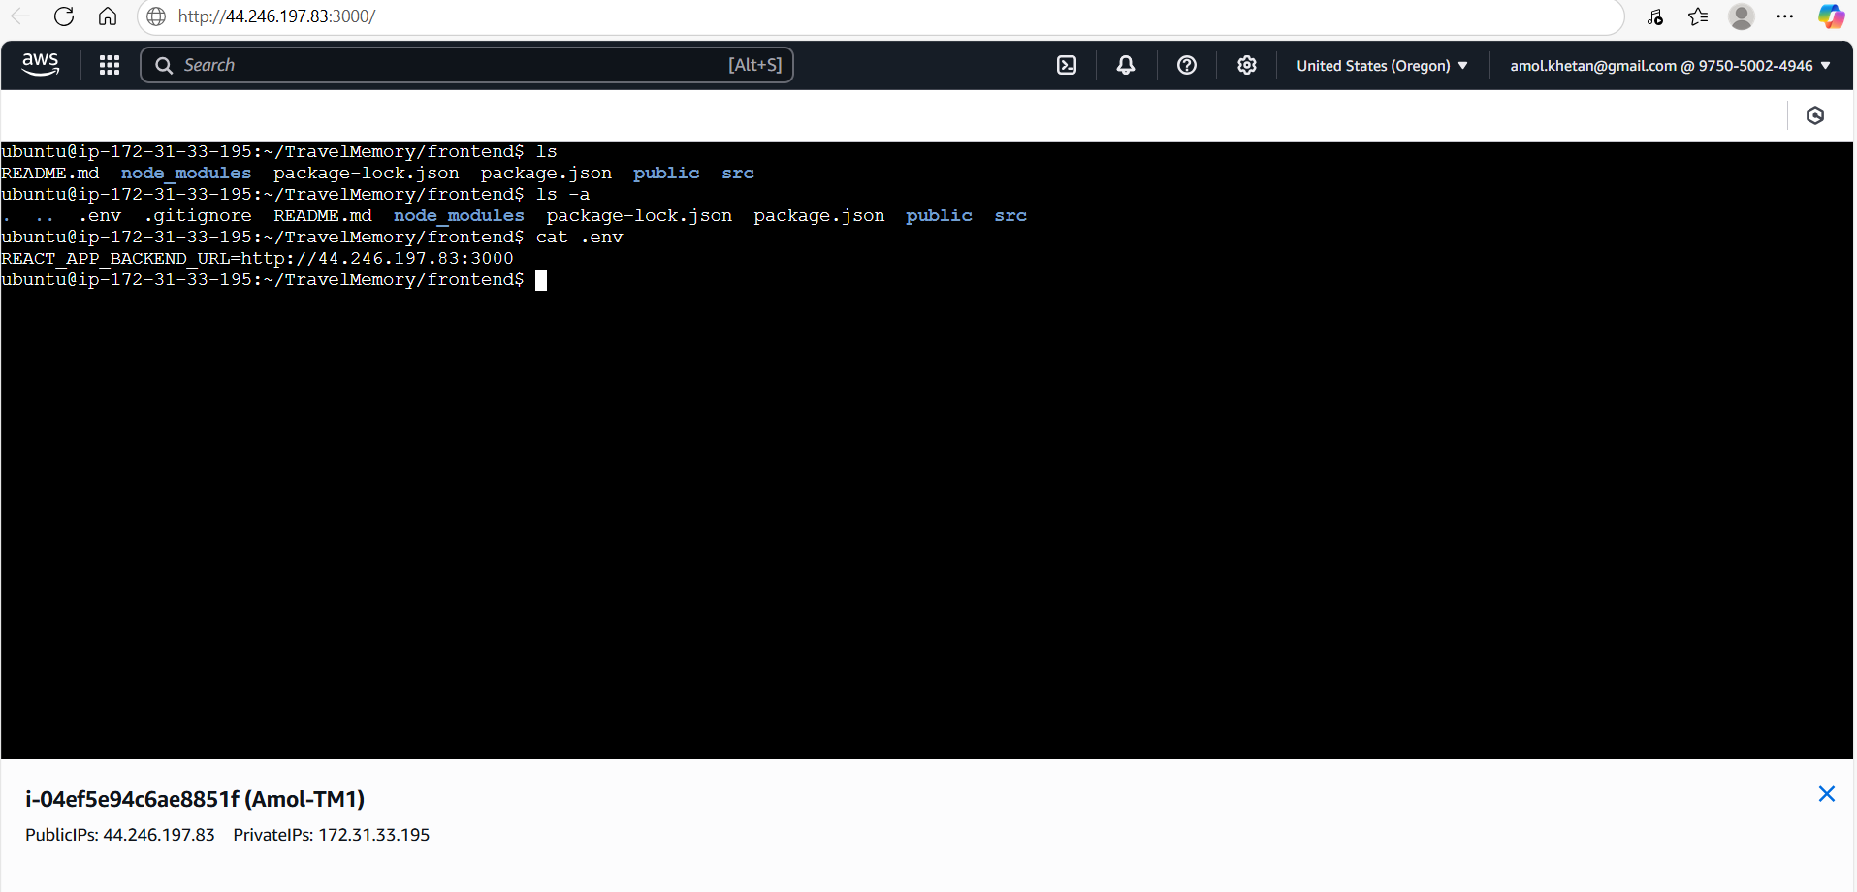

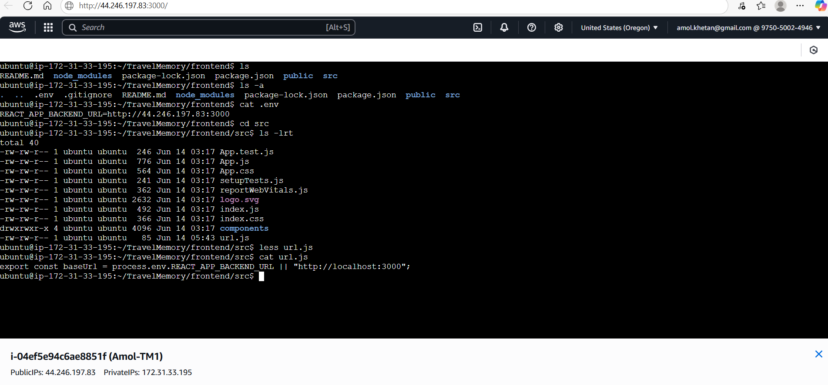

Run below command to install all dependencies

sudo npm install

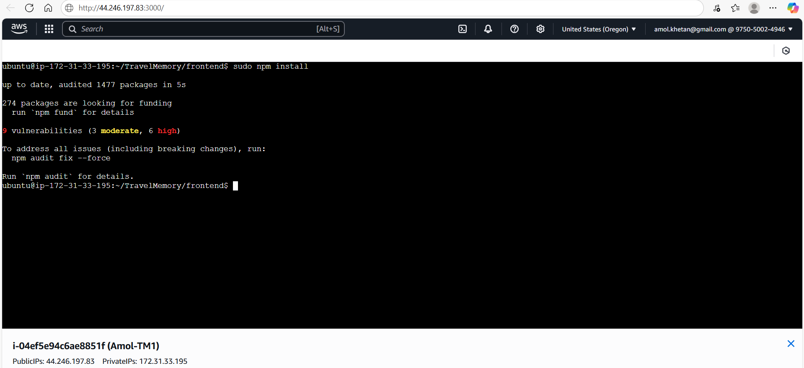

Now, start frontend

sudo npm start

Test frontend using using public ip of ec2 instance and port 3001

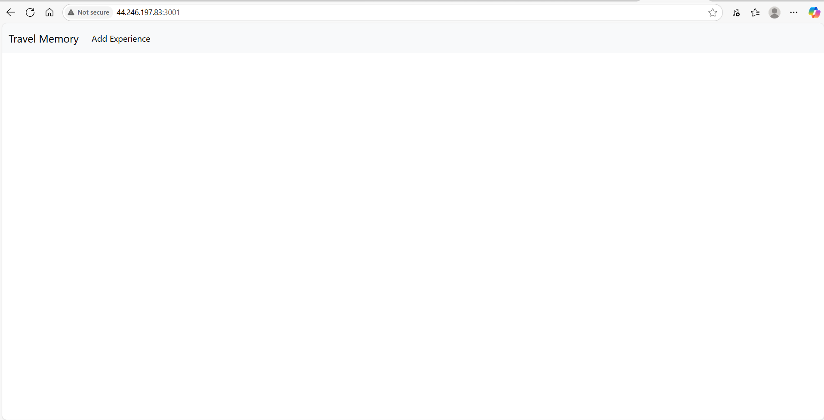

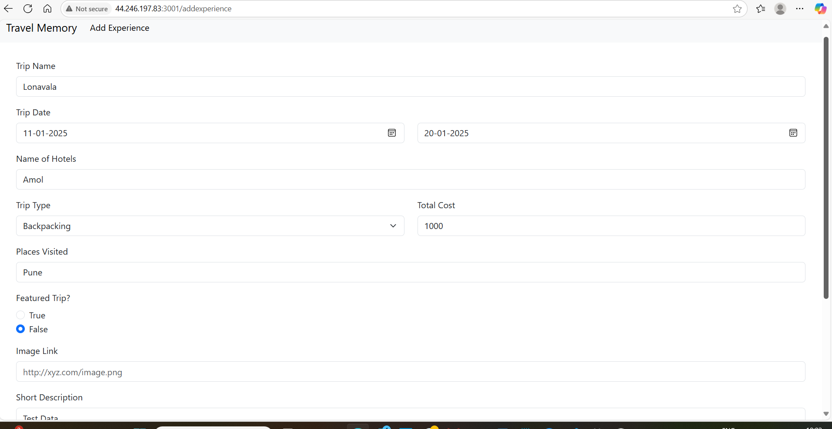

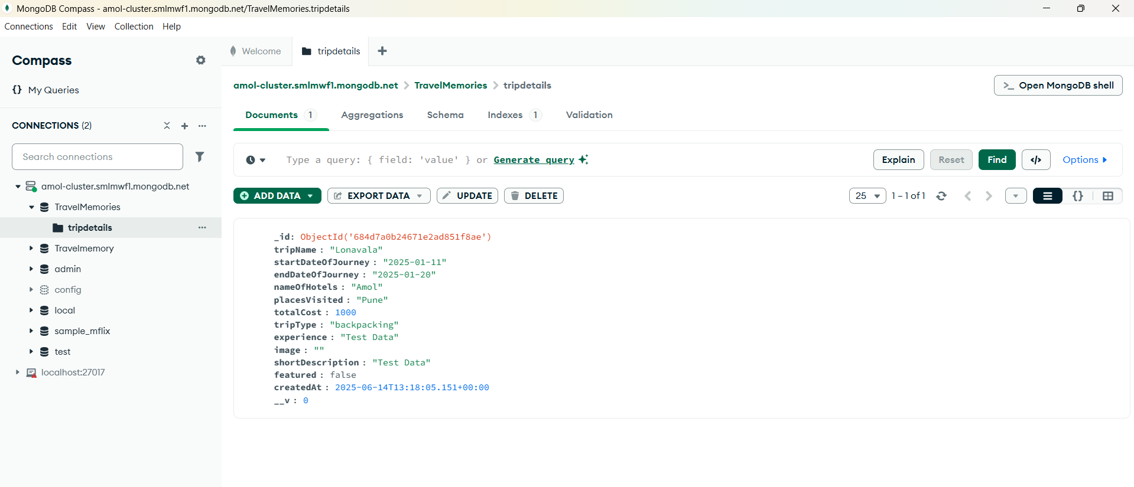

**Step 4:** Scaling the Application

Create AMI 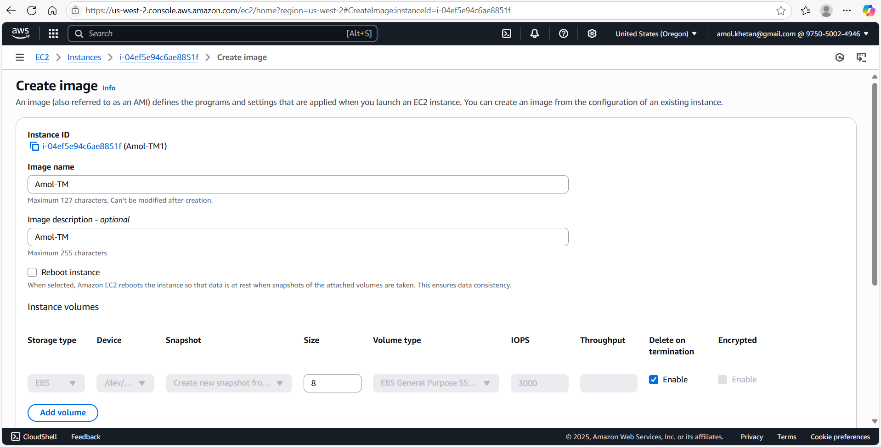

Create new instance using 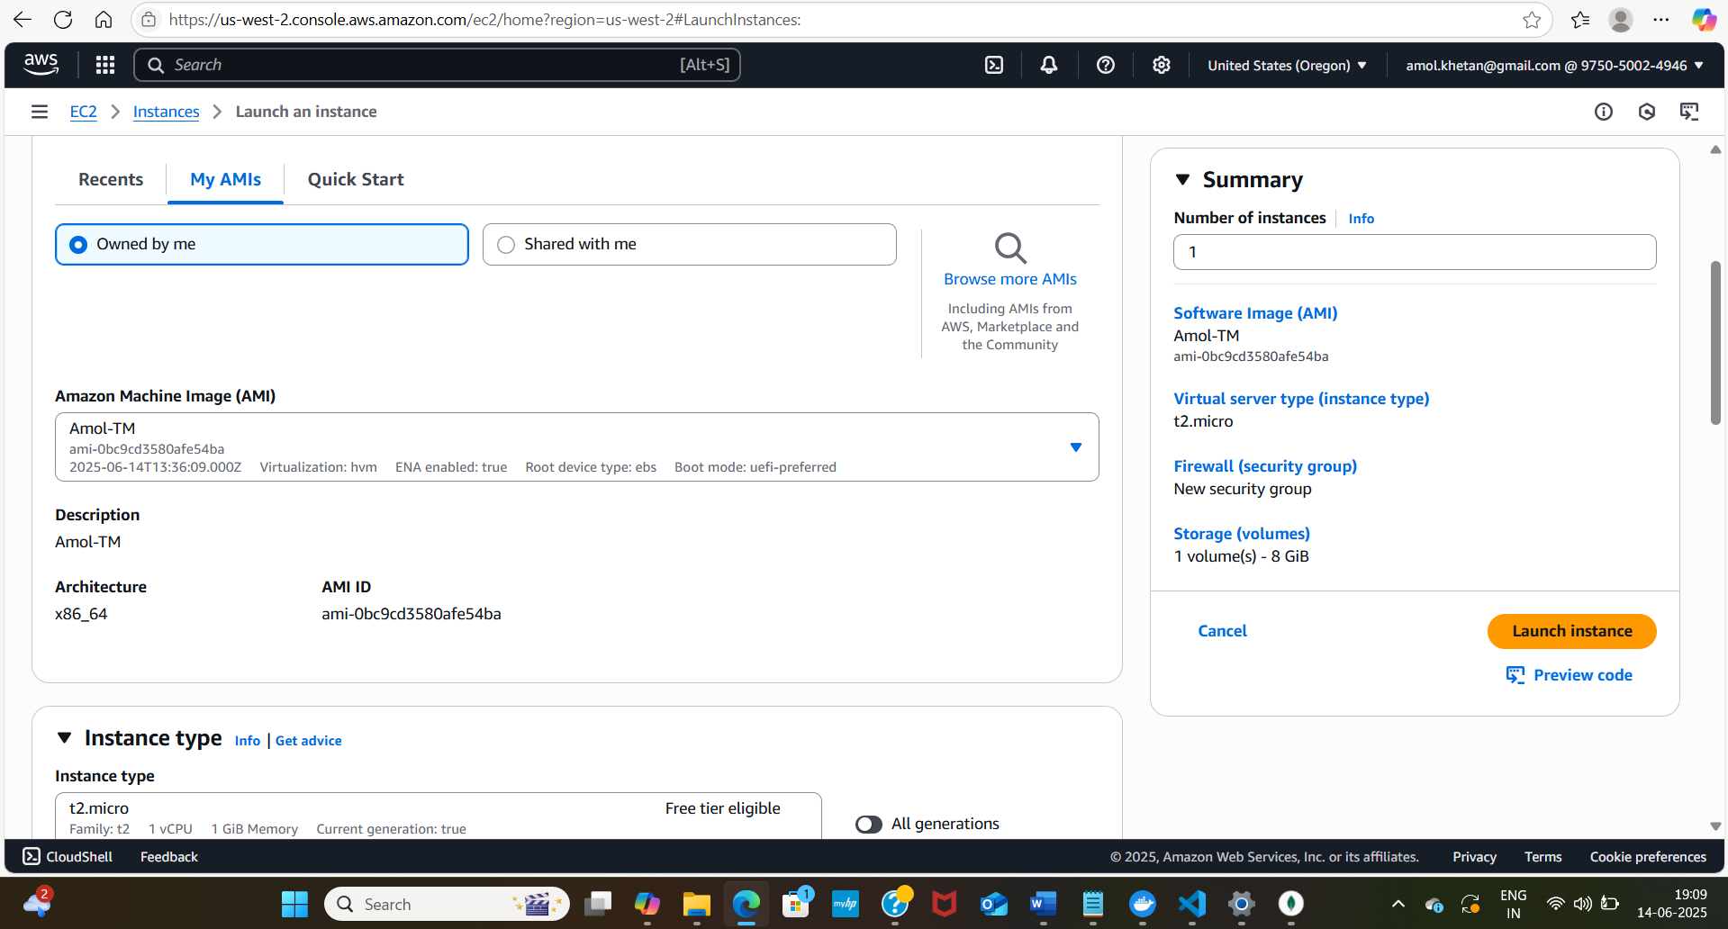

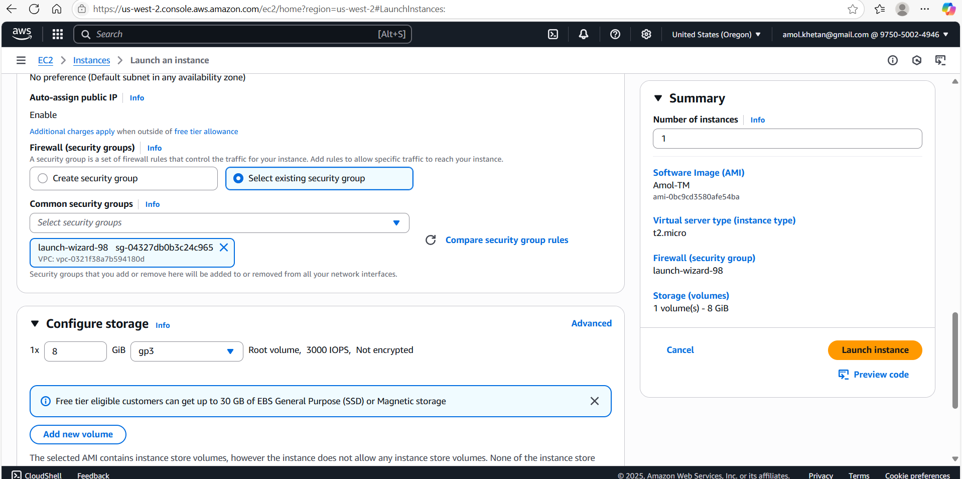

Connect to instance and start backend and frontend

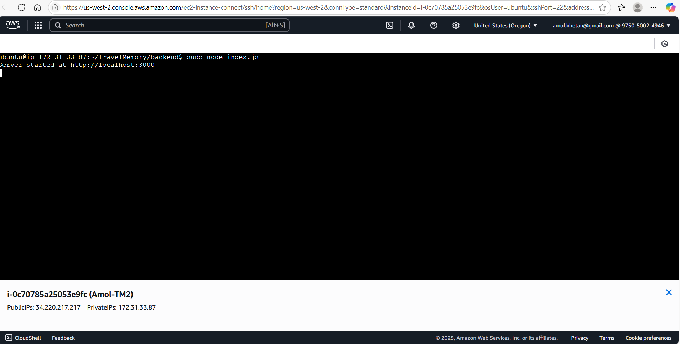

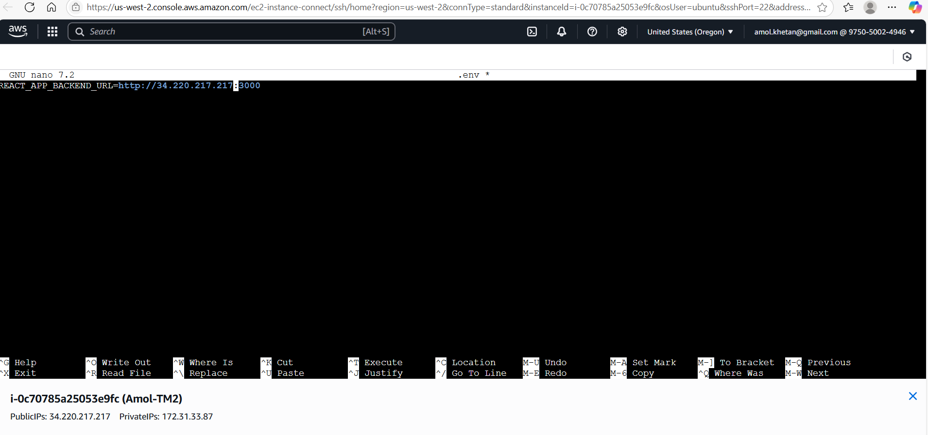

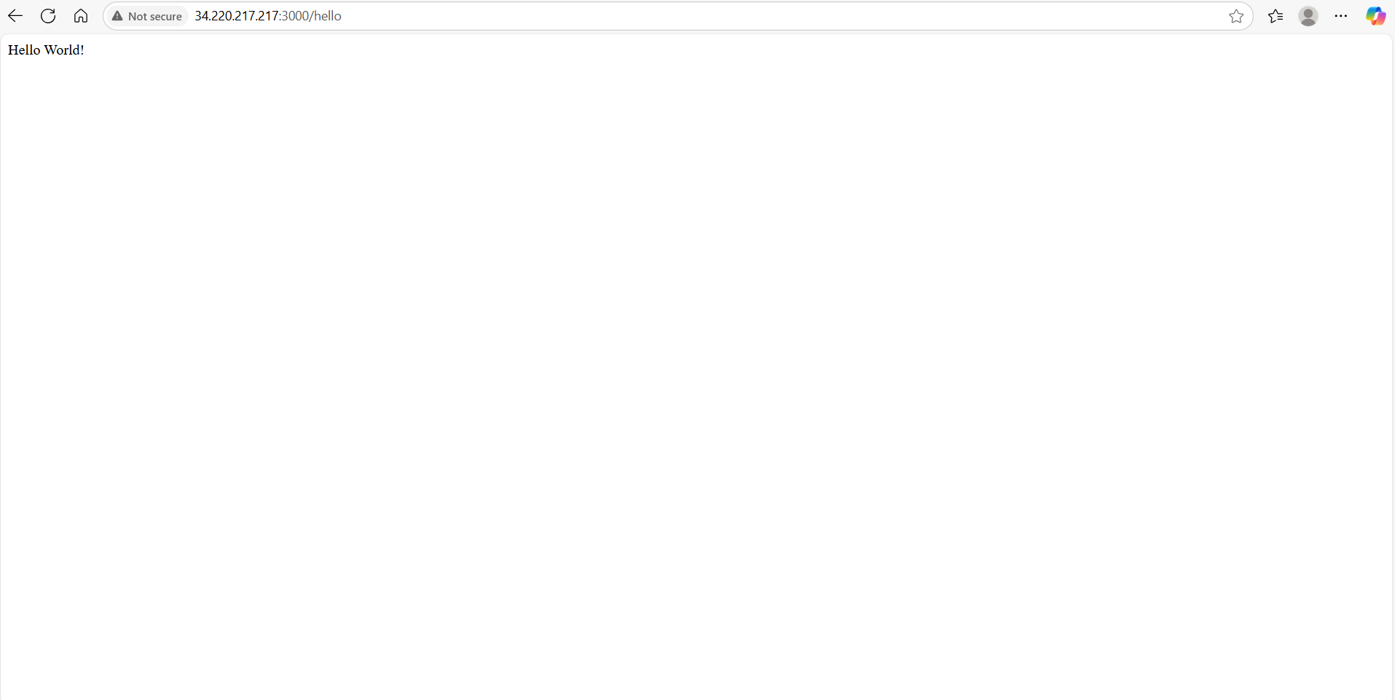

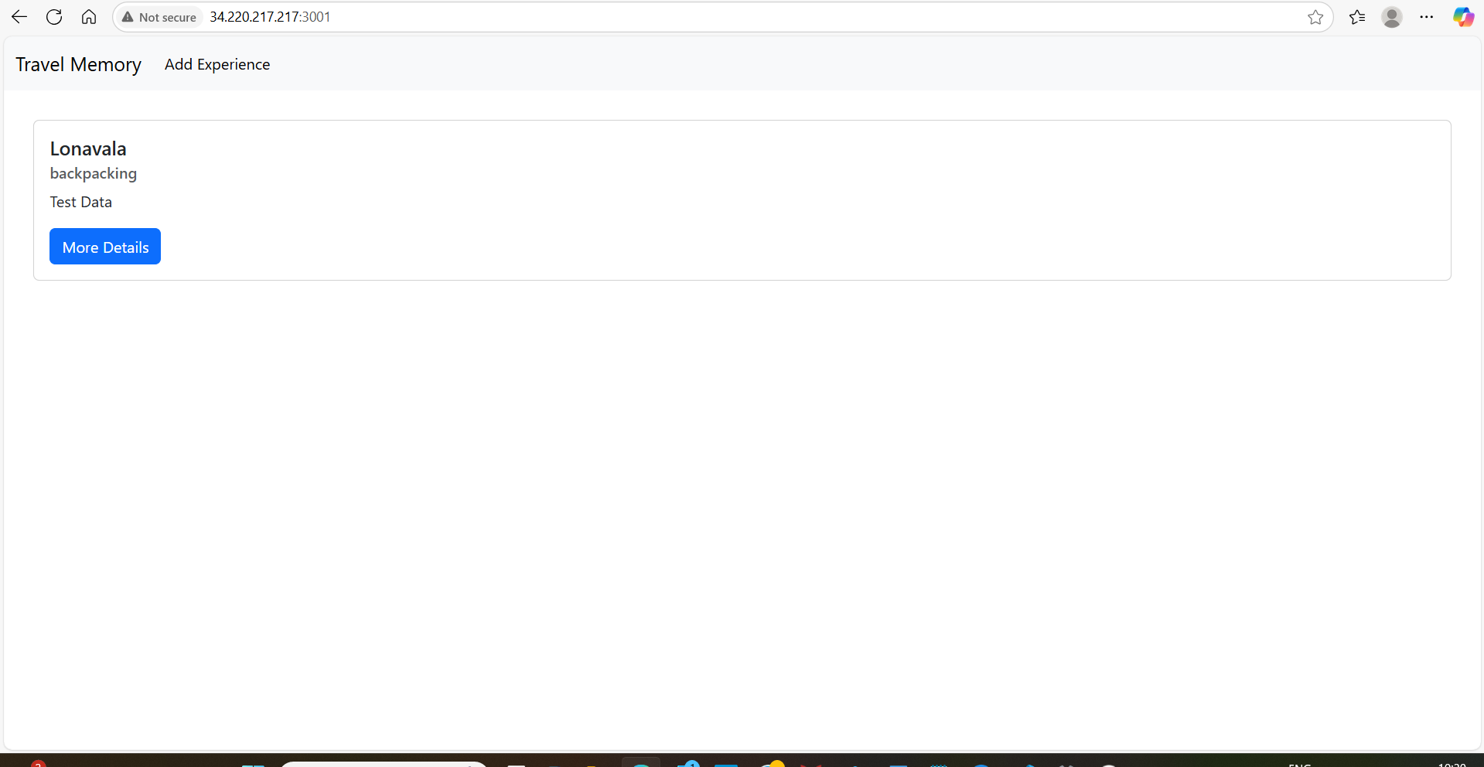

Create Target Group

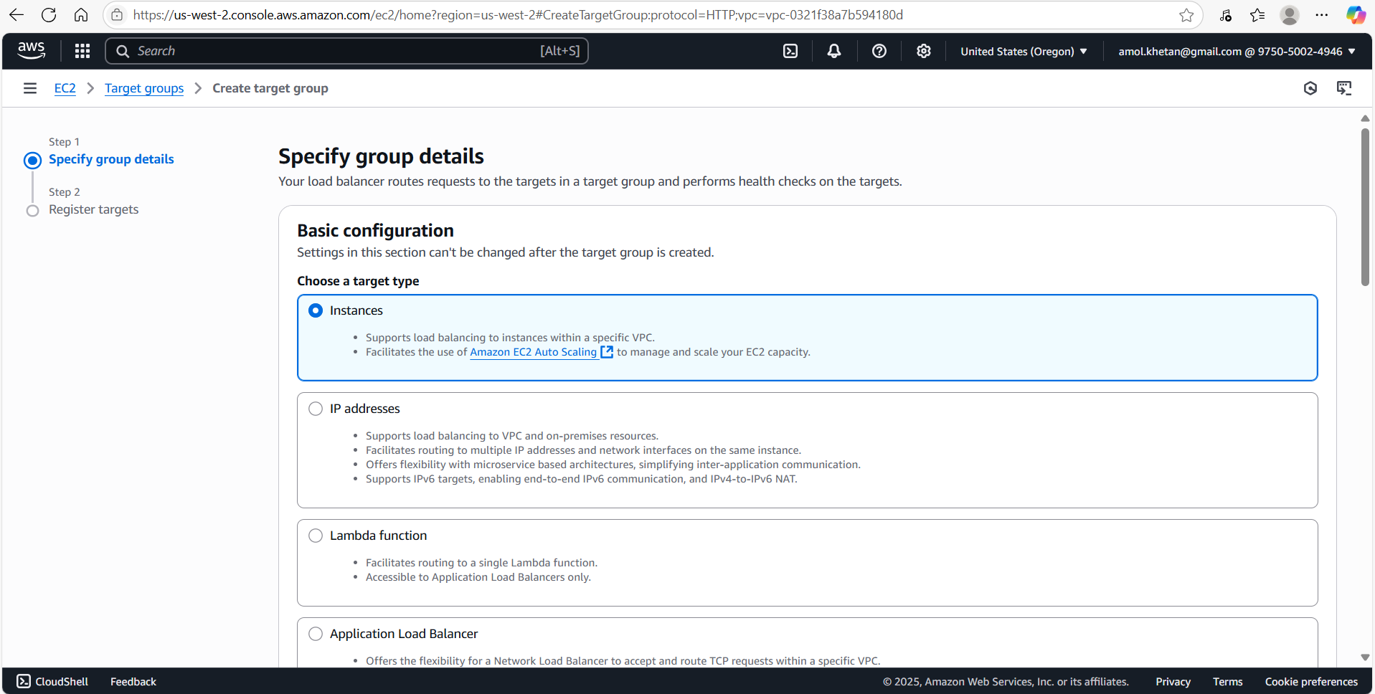

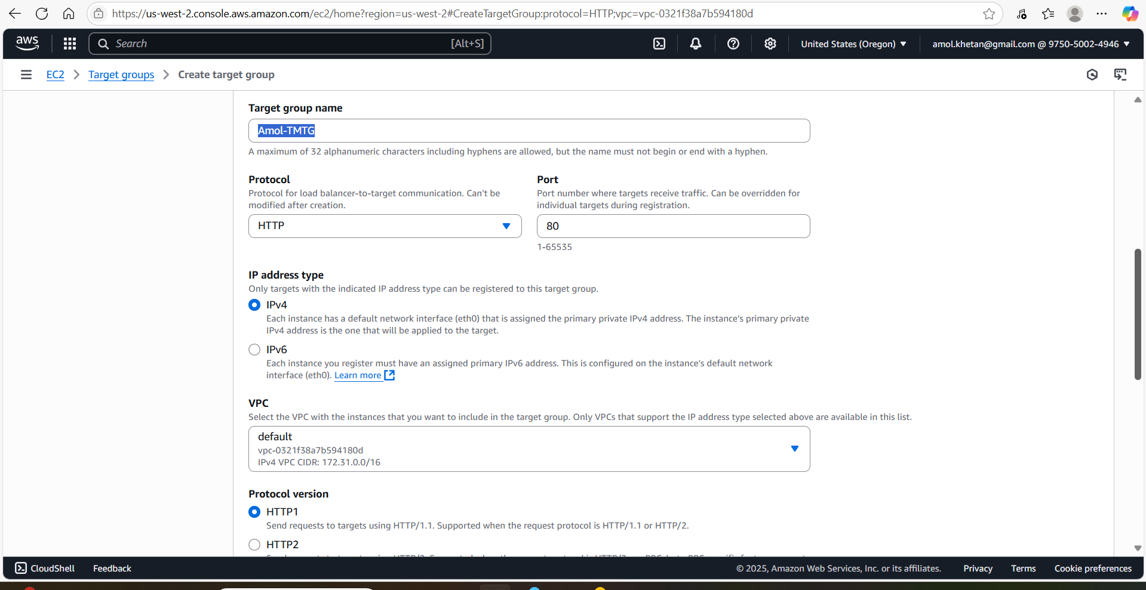

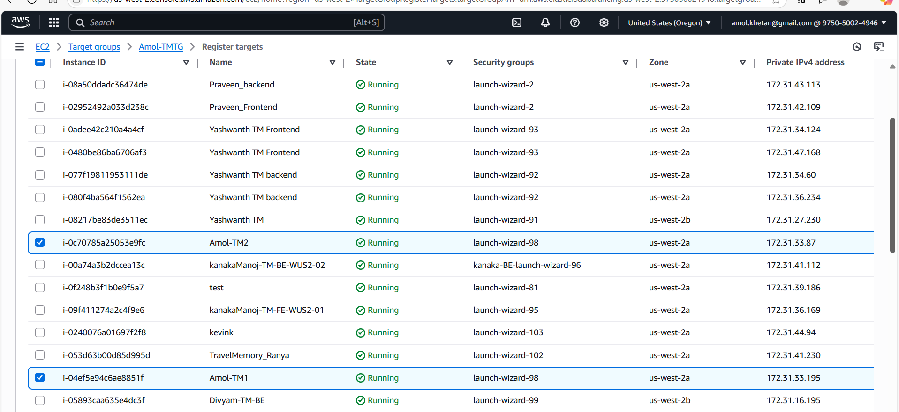

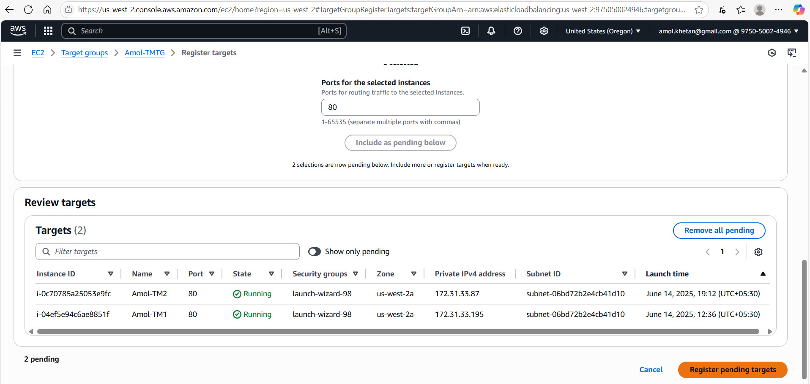

Create Load Balancer

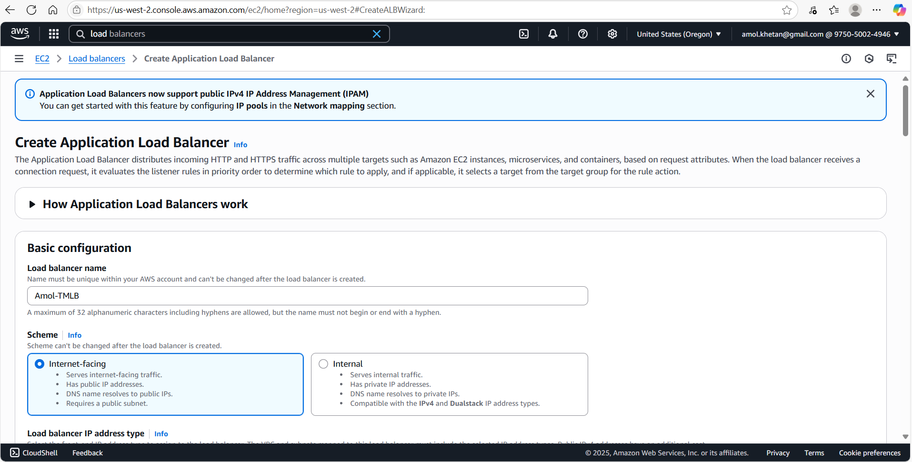

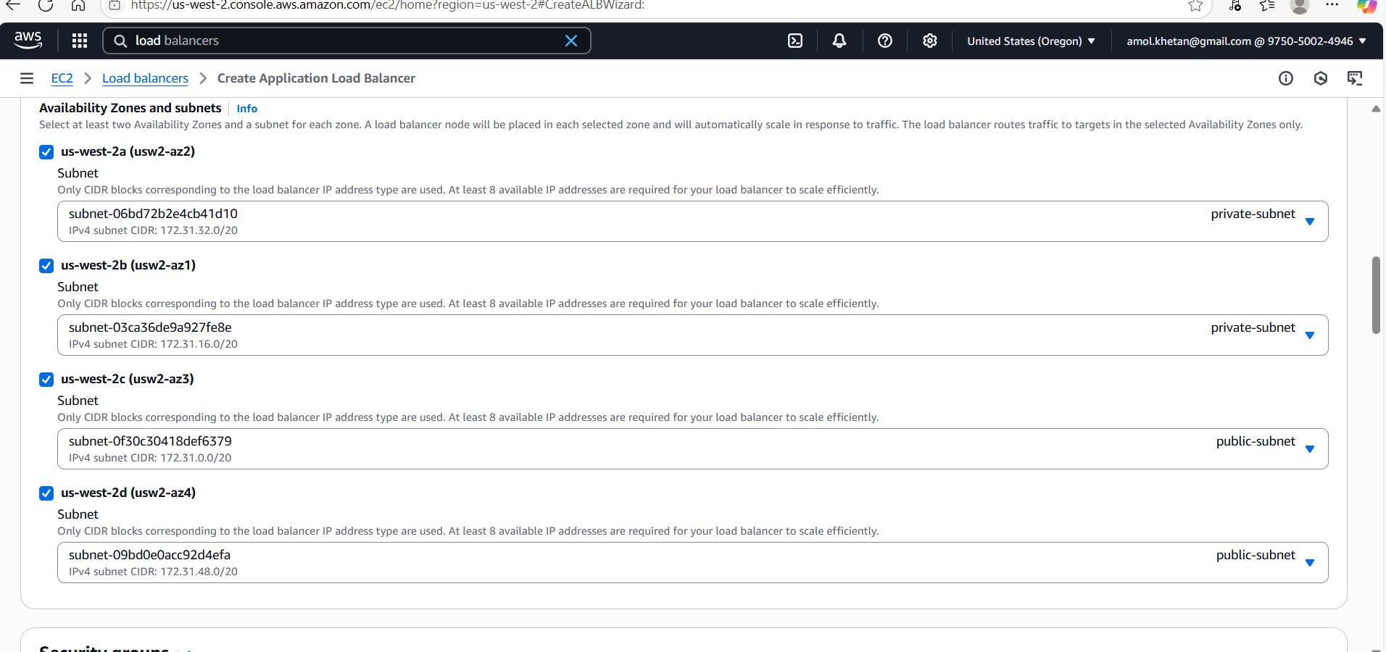

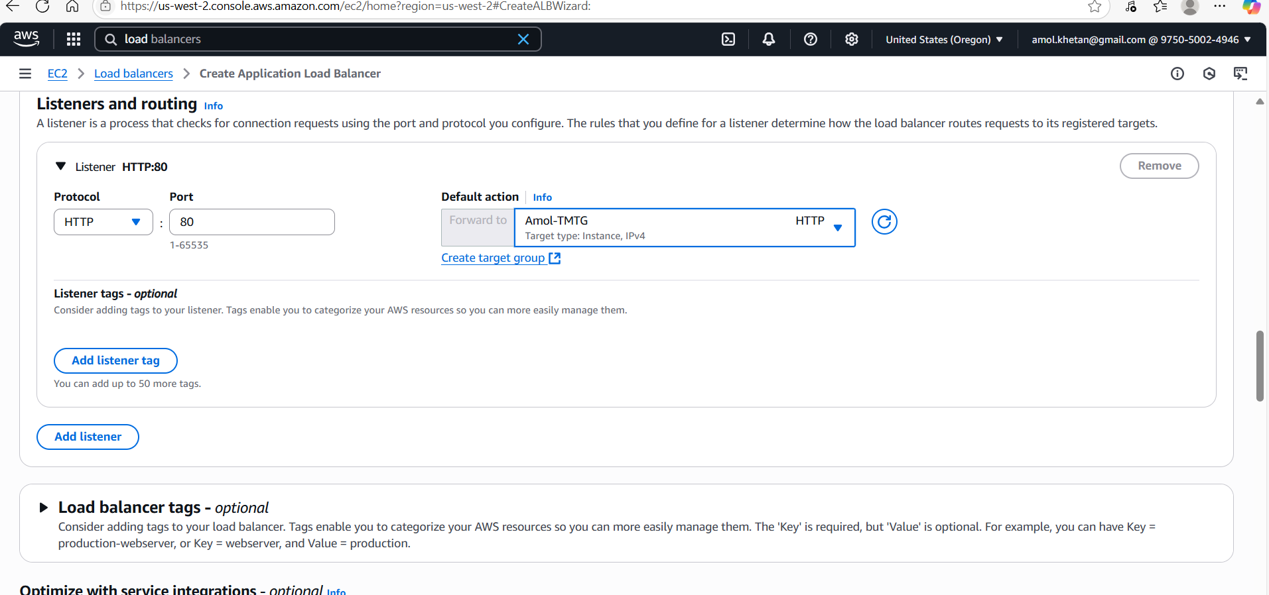

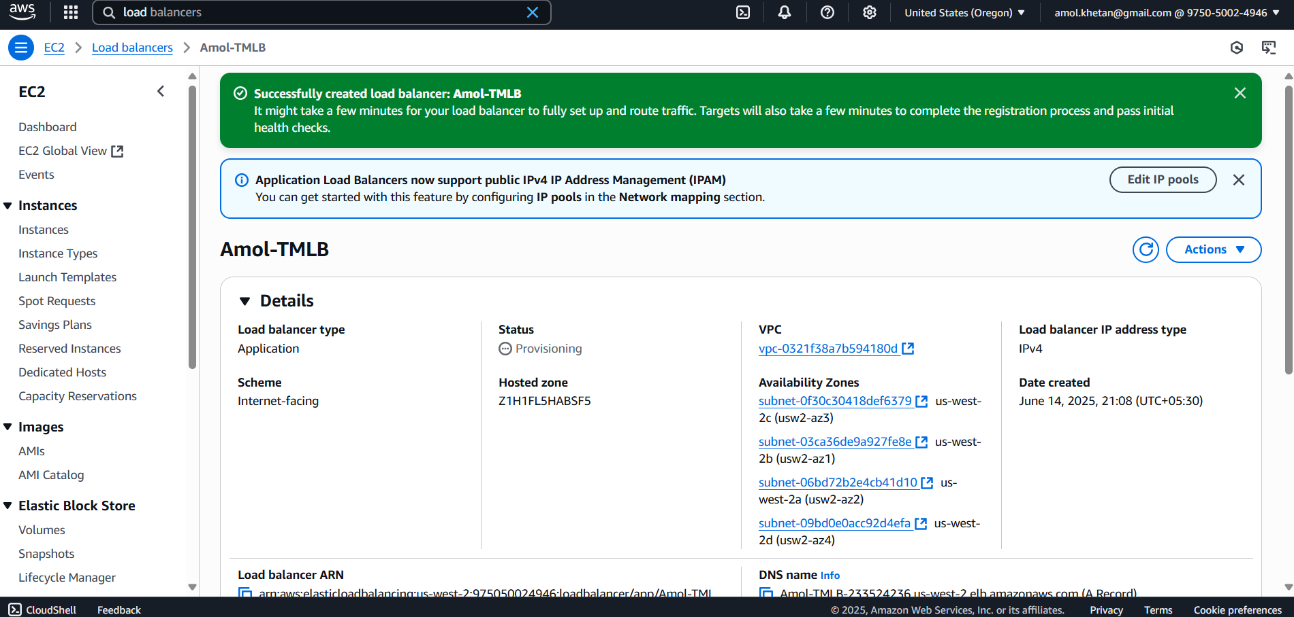

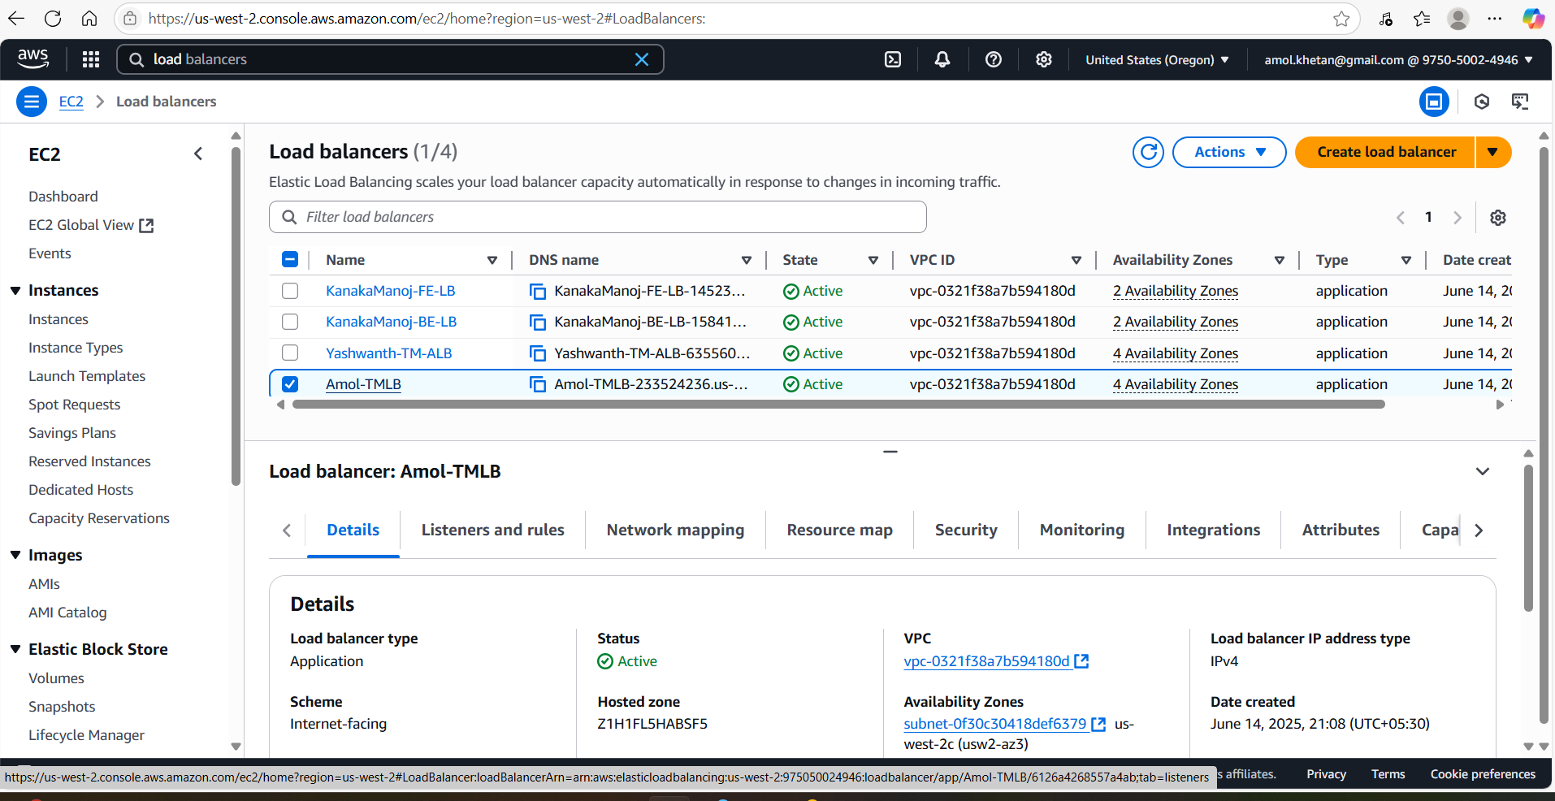

Test Application using ALB endpoint as shown below:

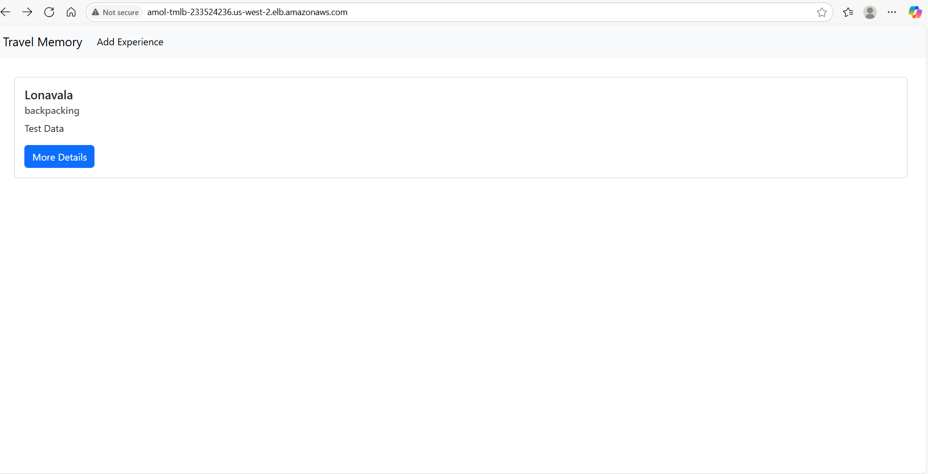

Update file to add ip address of ec2 machine to route properly

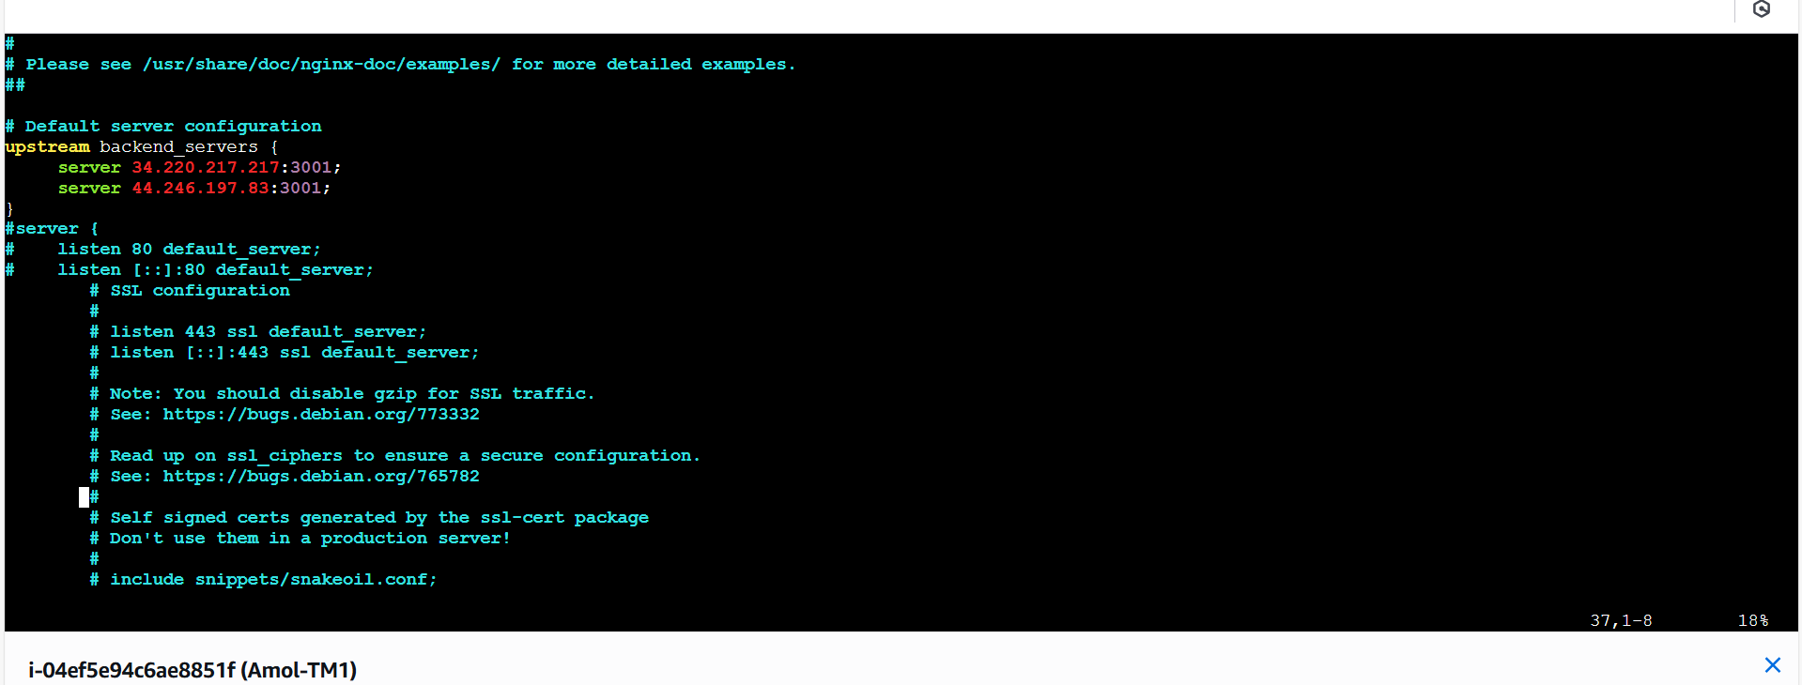

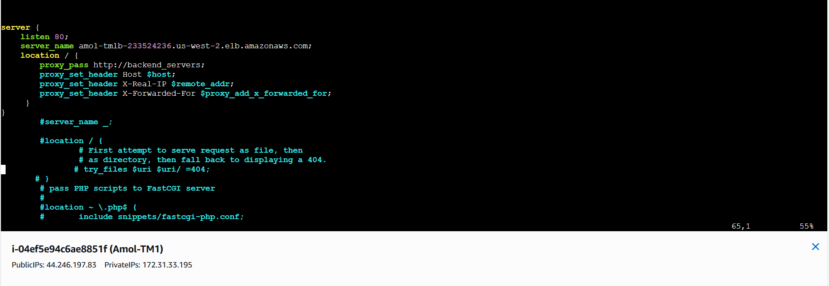

Step 5: Domain Setup with Cloudflare:

Like I created subdomain as travelmemory for my domain itworld.live

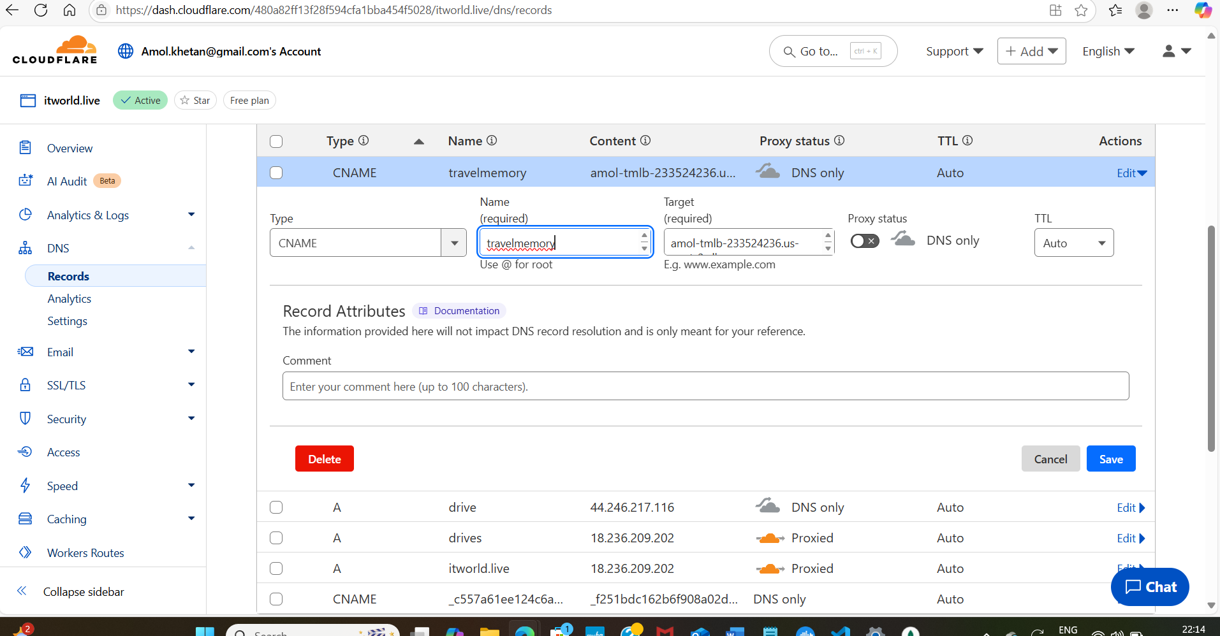

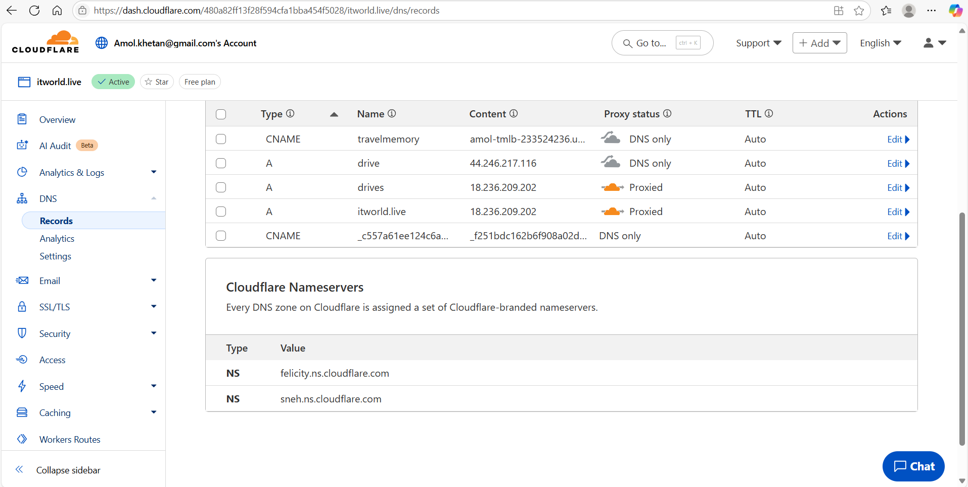

Test app using subdomain

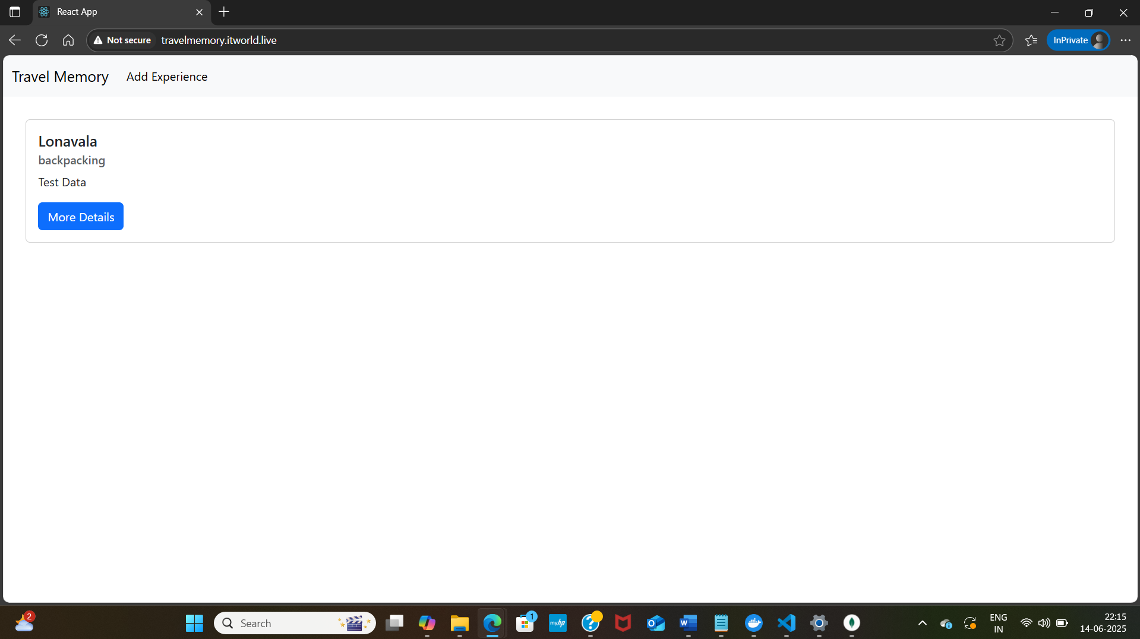

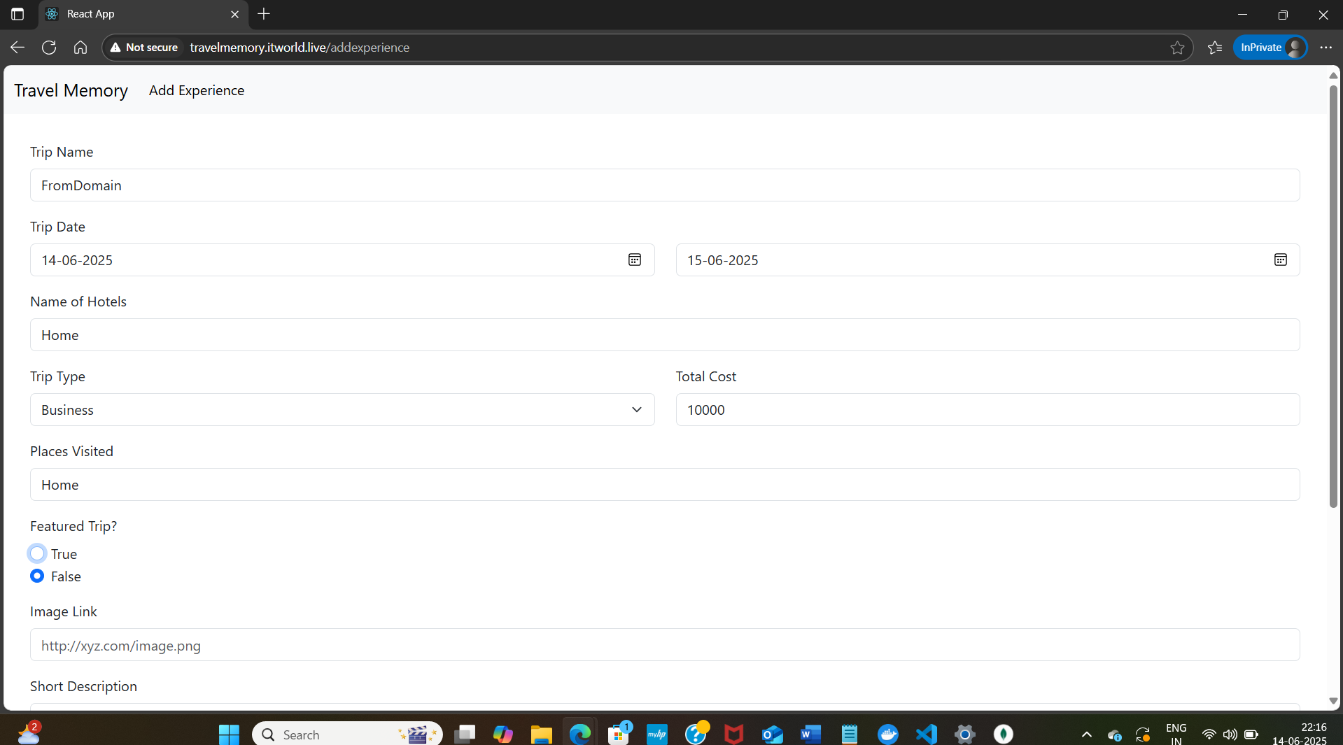

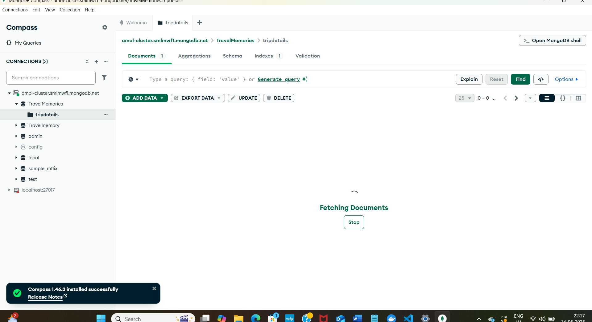

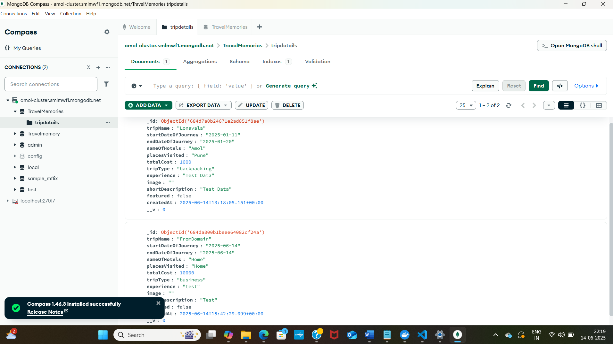

Added A record as well for Ec2 Machine’s ip and tested app with that as well

